Deforestation Analysis for Guinea

Methodology, Implementation and Accuracy Assessment
Table of Contents
Executive Summary 3
1. Introduction and Objectives 4
1.1 Background 4
1.2 Objectives 5
1.3 Scope and Limitations 5
2. Literature Review 5
2.1 Conceptual Framework for Deforestation Drivers 5
2.2 Forest Change Data Products 6
2.3 Spatial Modelling of Deforestation Risk 7
2.4 Land-Change Simulation Frameworks 8
2.5 Validation Practice in Land-Change Modelling 8
2.6 Regional Evidence: Guinea and the Upper Guinean Forest Belt 9
2.7 Existing Platforms and Benchmarking 10
2.7.1 Global Nature Watch (formerly Global Forest Watch) 10
2.7.2 Desktop and Open-Source Modelling Software 11
2.7.3 Benchmarking 12
2.8 Synthesis: Contribution of This Study 13
3. Study Area 13
4. Data and Justification 14
4.1 Design Principle 14
4.2 Land Cover (Targets) 14
4.3 Forest Change 15
4.4 Predictor / Driver Variables 15
5. Methodology 17
5.1 Preprocessing and Grid Alignment 17
5.2 Land-Cover Change Analysis 17
5.3 Transition Suitability Modelling 18
5.4 Allocation and Simulation 18
5.5 Forest Definition and Extent 18
5.6 Deforestation and Degradation Detection 18
5.7 Driver Attribution 19
5.8 Scenario Simulation 19
5.9 Implementation Approach 19
6. Validation and Accuracy Assessment 20
6.1 Why standard accuracy is not enough 20
6.2 Reported Metrics 20
6.3 Validation Design 21
7. Results 22
7.1 Land-Cover Change 22
7.2 Forest Cover and Loss 23
7.3 Forest Conversion 24
7.4 Deforestation Drivers 25
7.5 Candidate Predictors 27
7.6 Administrative Zone Breakdown 28
7.7 Model Accuracy 28
7.8 Future Scenarios 31
7.9 Data-Product Agreement (Hansen vs. ESRI) 32
7.10 Canopy-Threshold Sensitivity 33
7.11 External Benchmarking Against Global Nature Watch 33
8. Limitations and Uncertainty 34
9. Conclusions and Recommendations 36
10. References 38
Appendix A — Reproducibility 41
Appendix B — Data access date 42

Executive Summary
This study analyses land cover change-based forest loss in Guinea between 2018 and 2024, attributes the observed change to its spatial drivers, and simulates a future scenario to 2027. Using four annual land-cover maps (ESRI/Impact Observatory 10 m LULC for 2018, 2020, 2022, and 2024, resampled to a 250 m analysis grid) and 13 predictor variables (ten terrain/population/climate/accessibility surfaces, forest moisture, an adopted economic-driver surface – commodity price, confirmed via hold-out testing – and two forest-frontier distance surfaces), we find that the ESRI-based transition matrix and the Hansen-based canopy-loss record agree on the direction of change (net conversion of forest to rangeland) but disagree on how much of that loss the land-cover classifier actually registers as a class change.
Two independent lenses bracket forest loss over the period, both restricted to Guinea's actual national boundary throughout (Section 3). The ESRI land-cover transition indicates roughly 389,000 pixels of Trees converted between 2022 and 2024 (97.3% of it to Rangeland — consistent with every earlier epoch pair), while standing forest (Hansen canopy definition) declined from 5.46 million ha (2018) to 2.72 million ha (2024) — a net decline of 50.2% over six years (compound rate 10.96% per year); cumulative gross Hansen-detected loss within the 30% canopy mask over 2019-2024 is 2.74 million ha, which by construction equals the net extent decline and is confirmed independently by the canopy-threshold sensitivity computation (Section 7.6), which agrees to within 0.01%. Both products agree that conversion to rangeland is the dominant fate of cleared forest where a class change is registered at all: pixel-level agreement is 54.7%, Cohen's kappa 0.097 (Section 6.9), "slight" on the standard scale and near its lower bound. Most Hansen-flagged disturbance is not accompanied by an ESRI-registered class change (Section 7.3) — a genuine, three-times-confirmed finding (tested across three different comparison windows, not an artifact of any one of them) that canopy disturbance and land-cover class change are measuring related but distinct phenomena in this landscape, not simply two noisy estimates of the same thing.
Driver analysis identified distance to forest edge as by far the strongest spatial correlate of forest loss (importance 0.62), followed by land-surface temperature (0.09) and distance to prior loss (0.07); the adopted commodity-price predictor and the remaining terrain/population/climate/accessibility surfaces (elevation, slope, aspect, population density, precipitation, soil moisture, and distance to roads, railways, waterways, and point-of-interest density) each contribute more modestly (≤ 0.04), consistent with an edge- and frontier-driven pattern rather than one dominated by any single accessibility or economic factor. Results are intended as a regional screening and prioritization tool, not as a substitute for field-validated forest monitoring.
Two models were validated with an out-of-sample temporal hold-out rather than same-window metrics alone, which is the standard this report treats as authoritative – same-window metrics for the land cover model (Figure of Merit 78.9%, overall accuracy 97.2% within its own calibration window) are markedly more optimistic and are reported only as context in Section 7.7, not as the validated result. The deforestation risk model, after excluding a predictor (distance to forest edge) diagnosed as encoding period-specific frontier geometry rather than a transferable risk pattern, achieves a hold-out AUC of 0.564-0.689 across three independent historical calibration/test splits, most recent and most policy-relevant split at 0.689 (Section 7.7) – a legitimate basis for cautious spatial screening. A commodity-price predictor (palm oil, chosen for a literature-supported reason — palm oil expansion is a well-documented direct driver of tropical deforestation) was tested through the same protocol and adopted: it improved hold-out AUC on all three historical splits (+0.0095, +0.0059, +0.0038), the same bar the forest-edge exclusion had to clear, and is now a standard predictor in the adopted configuration. A second candidate, night-time lights, showed no decisive benefit (+0.0008, within run-to-run noise) and was not adopted. The land-cover change model, after correcting a confirmed label-noise issue and a predictor-alignment fault in the hold-out harness, and expanding to four land-cover epochs (enabling three hold-out splits — two 2-year splits plus a longer 4-year-horizon split), shows modest but genuine change-prediction skill: hold-out Figure of Merit of 15.9% and 15.6% on the 2-year splits, rising to 20.8% over the 4-year horizon, scaling with the amount of observed change as expected for this model class (Pontius et al., 2008). Its hold-out overall accuracy (91.1%, 91.1% and 86.8%) does not exceed the very high persistence baselines (94.0%, 93.8% and 92.3%) that short, low-change windows produce — an expected property of allocation models that commit to the full observed change demand — so the Figure of Merit, scored on change pixels only, is the metric this report treats as authoritative for this component: suitable for indicating where change is most likely, not as a pixel-exact forecast.

1. Introduction and Objectives

1.1 Background
Guinea, in West Africa, retains part of the Upper Guinean moist forest belt (one of the world's biodiversity hotspots) concentrated in the Guinée Forestière region in the country's southeast, alongside extensive Guinea savanna woodland across the interior. These wooded landscapes provide watershed protection for major West African rivers that rise in the Guinean highlands (including the Niger, Senegal and Gambia), supply timber and non-timber forest products, and store carbon.
Forest cover in Guinea is under pressure from several concurrent processes: expansion of smallholder and shifting cultivation, demand for fuelwood and charcoal, artisanal and industrial mining (Guinea is one of the world's largest bauxite producers), and infrastructure extension that opens previously remote areas to clearing. These proximate drivers are conditioned by demographic growth and by economic and institutional factors, following the general pattern for tropical deforestation described by Geist & Lambin (2002).
This exercise is performed to verify the deforestation analysis applied in the Guinea Environmental Digital Hub. The Deforestation module is included within the Land Use Analysis module and is the continuation analysis after the land use. However, the exercise and implementation are performed separately.

1.2 Objectives
1. Produce a consistent, multitemporal LULC record for Guinea from open data.
2. Quantify land-cover transitions and forest loss over the analysis period.
3. Identify the spatial factors associated with observed change.
4. Simulate future land cover and deforestation under alternative scenarios.
5. Report accuracy using methods accepted in the land-change literature.

1.3 Scope and Limitations
This is a remote-sensing and modelling study built entirely on open global datasets. It has not been validated against field data collected in Guinea (see Section 8). Results describe tree canopy and land cover as observed from space, which is not identical to legal forest status or land tenure.

2. Literature Review
This chapter situates this module’s analysis within the published literature on tropical deforestation monitoring, driver attribution, and spatial risk modelling. Its purpose is threefold: to establish that each analytical component adopted here is a published and validated method; to identify what the existing literature and operational platforms already provide for a country such as Guinea; and to state precisely what this analysis contributes beyond the existing ones. This section also benchmarks the outputs of this module against published figures from comparable work and from the reference operational platform for forest monitoring.

2.1 Conceptual Framework for Deforestation Drivers
The organizing framework for driver selection in this study is the underlying causes framework of Geist and Lambin (2002), which established through meta-analysis of 152 subnational case studies that tropical deforestation is rarely attributable to a single cause. It arises instead from combinations of agricultural expansion, wood extraction and infrastructure extension, themselves conditioned by demographic, economic, technological, policy and cultural factors. That framework remains the standard structure for driver-attribution work and directly determines the predictor categories used in this report; accessibility surfaces (distance to roads, railways, waterways), terrain, population pressure, climate, and economic-incentive proxy (commodity price).
Driver attribution has since become a mapped global product. Curtis et al. (2018) produced the first global classification of the dominant driver of forest loss, distinguishing commodity-driven deforestation, shifting agriculture, forestry, wildfire, and urbanization. This was superseded by Sims et al. (2025), produced by the World Resources Institute with Google DeepMind, which classifies the dominant driver of forest loss at 1 km resolution from 2001 onward across seven classes including permanent agriculture, shifting cultivation, hard commodities (mining), logging and settlements. Sims et al. trained a global neural network on approximately 7,000 interpreted reference samples, reporting an overall driver-classification accuracy of 90.5%, and found permanent agriculture to be the leading global driver at roughly 35% of loss over 2001-2022.
The existence of Sims et al. (2025) is directly relevant to the present study. It means that mapped driver attribution for Guinea is already available as a published product, and that the contribution of the drier analysis in this report is not the attribution itself but the fact that it is derived at the analysis resolution from a model that also produces a forward-looking risk surface (something the mapped product, being retrospective and descriptive, does not provide).

2.2 Forest Change Data Products
Hansen et al. (2013) established the reference global dataset for annual forest loss, derived from Landsat time series at 30 m, with a per-pixel lossyear band encoding the year of stand-replacement disturbance. This product underpins Global Forest Watch and, by extension, most operational forest monitoring worldwide. Its principal documented limitation for the present purpose was raised by Tropek et al. (2014), who noted that the product maps canopy disturbance without distinguishing natural forest from plantations, and therefore answers the question “was canopy lost here” rather than “what land cover class is this now”. This distinction is not incidental to this module – it is the source of the divergence between the two measurement lenses quantified here.
For land cover, Karra et al. (2021) produced the ESTI / Impact Observatory annual 10 m product from Sentinel-2 using a deep-learning classifier, and Brown et al. (2022) produced Dynamic World, providing near-real-time 10 m land cover from the same sensor. Venter et al. (2022) compared Dynamic World, WorldCover, and ESRI Land Cover directly and found substantial disagreement between them, establishing that 10 m global land cover products are not interchangeable and that disagreement between products should be treated as label noise rather than resolved by arbitrary selection. This finding is the reason this module reports the Hansen and ESRI lenses side by side rather than reconciling them into a single figure, and the reason cross-product agreement is reported as a diagnostic.
For the moist-forest southeast specifically, Vancutsem et al. (2021) produced the JRC Tropical Moist Forest dataset, which distinguishes degradation from deforestation and is calibrated to the humid tropics. Its coverage does not extend across Guinea's savanna interior, which is why it is retained in this report as a recommended supplement rather than adopted as a national layer.

2.3 Spatial Modelling of Deforestation Risk
Spatially explicit deforestation risk modelling has a substantial methodological literature and, unusually for this field, an established certification standard.
Vieilledent (2021) released forestatrisk, an open-source Python package for modelling and forecasting tropical deforestation that uses the same predictor families adopted here: topography (elevation, slope, aspect), accessibility (distance to roads and towns), distance to forest edge, distance to previous deforestation, and protected-area status. The package supports logistic regression with spatially autocorrelated random effects (iCAR), plain logistic regression, and Random Forest. Its published worked examples contain a directly relevant result: for the New Caledonia case study, the Random Forest specification explains 84% of the deviance against 42% of the iCAR specification, yet performs worse under cross-validation. This is an explicit, documented demonstration that Random Forest overfits this problem class. This is the same failure mode diagnosed and corrected in this report through the exclusion of distance to forest edge, and it is the principal reason the same-window AUC of 0.994 reported here is presented as context rather than as a result.
Verra (2024) published VT0007 Unplanned Deforestation Allocation, developed by Clark Labs with TerraCarbon, which defines a standardized procedure for constructing deforestation risk maps from historical loss and spatial predictors, and for allocating jurisdictional deforestation to projects on the basis of that risk. The accompanying open-source implementation, UDef-ARP, fits a model over a Calibration Period, tests it over a distinct Confirmation Period, and only then applies it to the Validity Period. Two features of that standard are worth stating explicitly, because the design of this study conforms to both:
- Separation of calibration, confirmation, and application periods. VT0007 requires that a candidate risk model be tested on a period distinct from the one it was fitted on. This is the discipline applied in this report, where three independent historical calibration (test splits) are used and same-window metrics are explicitly rejected as evidence of forward predictive skill.
- Benchmark-versus-alternative comparison. VT0007 constructs a benchmark model from minimal data and requires any alternative model to demonstrate improvement against it before adoption. The predictor-adoption protocol used in this report applies the same logic at the predictor level. This is where a candidate predictor is adopted only if it improves hold-out AUC on every historical split, yielding one adoption (commodity price) and three rejections (NDVI, burned area, nighttime lights).
The Random Forest classified itself (Breiman, 2001) is used here for the reason standard in this literature. It accommodates non-linear relationships and correlated predictors without distributional assumptions, and its variable importances support interpretable driver attribution.

2.4 Land-Change Simulation Frameworks
The land-cover change and allocation component of this study follows the pattern-based modelling archetype established in the land-change science literature. Verburg et al. (2002) introduced CLUE-S, which allocates projected demand across a landscape subject to spatial policy and land-use conversion constraints. Soares-Filho et al. (2002) introduced DINAMICA, a stochastic cellular-automata model designed for Amazonian colonization frontiers, which is the origin of the Expander and Patcher distinction between edge-adjacent and spontaneous growth used in the growth-mode variant tested in this report.
Mas et al. (2014) provide the definitive comparison of the four most widely used pattern-based packages (CA_MARKOV, CLUE, DINAMICA, and Land Change Modeler), evaluating them on quantity-of-change estimation, change-potential evaluation, spatial allocation, model evaluation and usability. Their analysis establishes both that these packages share a common archetypal structure and that they differ materially in implementation detail: DINAMICA, for instance, requires user-defined binning of continuous explanatory variables, a step that strongly conditions its results. Yi et al. (2012) compared CLUE-S and DINAMICA EGO directly and found CLUE-S stronger on overall accuracy while DINAMICA’s Markov component more precisely reproduced the quantity of change.
The implementation in this study follows the same archetype (quantity estimation, transition-potential evaluation, spatial allocation, validation), and departs from these packages only where a platform deployment requires is: live data ingestion in place of locally prepared rasters, continuous predictors used without binning, server-side execution, and an open-source stack.

2.5 Validation Practice in Land-Change Modelling
The validation standard applied in this module is drawn from the land-change accuracy literature.
Pontius and Millones (2011) established the case against the Kappa family of indices for comparing simulated against observed maps, proposing instead the decomposition of total disagreement into quantity disagreement (wrong amount of each class) and allocation disagreement (right amount, wrong location). This report follows that guidance for simulated-versus observed comparison, while retaining Cohen’s kappa for the distinct purpose, measuring agreement between two independent data products, a comparison not subject to the same critique and interpreted against the categorical scale of Landis and Koch (1977).
Pontius et al. (2008) introduced the Figure of Merit, scored on change pixels only, and reported the benchmark result most relevant to interpreting the values in this study: in a comparison of 13 applications of 9 land-change models, error exceeded correctly predicted change in 12 of the 13 cases. Modest Figure of Merit values are therefore the norm in this literature, not an anomaly. Pontius and Malanson (2005) established the null persistence model (relabelling the earlier map as the prediction for the later date) as the baseline any change model must be measured against.
Roberts et al. (2017) established that random cross-validation systematically underestimates predictive error for spatially structured data, because a random split places near-duplicate samples on both sides of the partition, and that spatially blocked cross-validation is the standard remedy. This report reports both figures and the optimism gap between them, which is reported in only a minority of published applications in this field.
Olofsson et al. (2014) set out good practice for area estimation, requiring a probability sample of reference data to adjust mapped areas for classification error and report them with confidence intervals. No such sample was available for this run, which is recorded as one of the limitations in this report.

2.6 Regional Evidence: Guinea and the Upper Guinean Forest Belt
Guinea lies within the Guinean Forests of West Africa biodiversity hotspot, a region that is substantially under-represented in the deforestation modelling literature relative to the Amazon and Southeast Asia. This regional gap is part of the justification for the present work.
The Guinea-specific evidence base that does exist is directly relevant to the interpretation of results in this report:
- Magnitude and drivers: Fitzgerald et al. (2021) analyzed tree cover loss and its proximate drivers across Guinée Forestière using Landsat analysis-ready data and a regionally calibrated annual change-detection model, with drivers identified from a statistical sample of interpreted reference data. They report total tree cover loss of 10,907 km2 (SE 889 km2) between 2000 and 2018 (approximately 25% of the region’s land area) of which 364 km2 (SE 91 km2) occurred within protected areas of high biodiversity value. Smallholder agriculture, both subsistence and cash-crop, was identified as the primary proximate driver. This is one of very few Guinea-specific studies to have used an independent reference sample rather than product-to-product comparison, and it is therefore the most appropriate external benchmark available for the regional results.
- Vegetation dynamics and the limits of greenness indices: Liu et al. (2017) characterised vegetation dynamics across the Upper Guinean forest region from MODIS data for 2001–2015, comparing six spectral indices against manually interpreted measurements of woody cover. They found the tasseled cap wetness index most strongly associated with woody vegetation cover, while greenness indices such as EVI showed comparatively weak associations. This result provides independent regional support for a finding of the present study: the NDVI predictor tested in this report did not carry transferable predictive signal for forest loss and was rejected. In this specific landscape, greenness is a weak discriminator of woody cover, and moisture-related signals are stronger.
- Degradation as a distinct process: Vo Quang et al. (2022) demonstrated for Guinea specifically that degraded forests are separable from intact forests using Sentinel-2 short-wave infrared radiometry, because the more open canopy of degraded forest produces additional dry-season desiccation, and that incorporating spatial context into a Random Forest classification improves detection. Vo Quang et al. (2025) extended this with convolutional neural networks, reporting 94% accuracy for a U-Net model in the Ziama massif and over 91% in Mount Nimba, a site excluded from training, and adopted the model for forest class updates in the national land cover map produced for the Guinean Ministry of Agriculture. Both studies confirm that selective logging is the dominant degradation process in Guinean massif forests.
This last body of work supplies the physical explanation for the central empirical finding of this report. Degradation in Guinea is widespread, is dominated by selective logging, and by definition alters forest structure without producing a land-use change. Canopy disturbance detected by Hansel will therefore frequently occur without any accompanying land-cover class transition in the ESRI product. The divergence between the two lenses reported in this study is consistent with the independently documented character of forest change in this landscape, and is not an artefact of the comparison.

2.7 Existing Platforms and Benchmarking

2.7.1 Global Nature Watch (formerly Global Forest Watch)
Global Forest Watch, established by the World Resources Institute and launched in its interactive form in 2014, has been the reference open platform for forest monitoring for over a decade. It has since been rebranded as Global Nature Watch, extending coverage from forests to grasslands, wetlands, croplands, pastures and carbon fluxes. Its AI-assisted interface, Global Nature Watch Horizon, was developed with Land & Carbon Lab (an initiative convened by the World Resources Institute and the Bezos Earth Fund) and combines more than 80 peer-reviewed datasets behind a natural-language query interface that resolves requests into deterministic geospatial analyses.
Global Nature Watch is authoritative for observed change, and this report treats it as the external reference against which the observed-change figures reported here should be checked. Its documented capabilities are, however, explicitly descriptive. The platform’s own capability documentation enumerates the supported analysis types (area-based summaries, temporal analysis, trend analysis, before/after comparison, cross-location and nested-area comparison, dataset class comparison, and raking) and lists predictive modelling and forecasting as not supported. Analysis is further restricted to predefined areas of interest (administrative units, protected areas, key biodiversity areas, indigenous and community lands, or uploaded polygons under 1 MB); continental and ecosystem-scale areas and buffer-based areas of interest are not supported, and custom map outputs are not supported.
The relationship between the two systems is therefore one of function:
Table 1. Functional comparison, Global Nature Watch and the present platform.
Capability | Global Nature Watch | This platform
Observed forest and land cover change | Yes; authoritative, including weekly alerts | Yes; derived from the same underlying products
Driver attribution | Yes, as a published 1 km mapped product (Sims et al., 2025) | Yes, model-derived at analysis resolution
Spatial risk ranking of standing forest | Not provided | Yes (Section 7.4)
Simulation of future land cover | Not supported | Yes (Section 7.8)
Forecasting | Not supported | Yes (Section 7.8)
Policy scenario testing (protected areas, frontier expansion, demand override) | Not supported | Yes (Sections 5.8, 6.8)
Buffer-based and custom analysis areas | Not supported | Yes
Custom national-scale map outputs | Not supported | Yes
Designed for integration with a national system | No | Yes
Global Nature Watch answers what has happened. The system documented in this report is designed to answer what is likely to happen next, and how that changes under a specified policy. The appropriate relationship is for platform to use Global Nature Watch as an external validation reference for observed change, and to add the predictive and scenario layer that the reference platform does not provide.

2.7.2 Desktop and Open-Source Modelling Software
Neither ArcGIS Pro nor QGIS provides land-change simulation or deforestation risk mapping as a core capability. The established tools are separate products: Land Change Modeler, distributed with Clark Labs’ TerrSet (proprietary); DINAMICA EGO (Soares-Filho et al., 2002); the CLUE family (Verburg et al., 2002); UDef-ARP, the open-source reference implementation of Verra VT0007; and forestatrisk (Vieilledent, 2021), available as a Python package and through the deforisk QGIS plugin.
These are analyst tools rather than decision-support systems. Each requires locally prepared input rasters, a trained operator and a per-analysis manual workflow. None provides live data ingestion, a web-accessible dashboard, or a scenario interface usable by a non-specialist government user. The gap this work addresses is not methodological but operational: between a capable desktop modelling tool and a deployable national decision-support platform.

2.7.3 Benchmarking
Direct accuracy comparison against Global Nature Watch is not possible, because that platform produces no prediction that could be scored against an observation. Benchmarking is therefore performed on three tiers: agreement of observed-change data with the reference platform is a result of this analysis and is reported in Section 7.11, conformance of method to the recognized standard, and comparison of reported metrics against published ranges.
Method conformance. Conformance is stated against the recognized standard for each element:
Table 3. Conformance of this study’s design against published standards.
Element | Standard | This study
Calibration / confirmation / application period separation | Verra (2024), VT0007 | Conforms; three independent historical splits (Section 7.7)
Predictor adoption on demonstrated improvement | Verra (2024), benchmark-vs-alternative logic | Stricter; improvement required on every split, not one
Figure of Merit on change pixels | Pontius et al. (2008) | Conforms (Section 7.7)
Null persistence baseline reported | Pontius and Malanson (2005) | Conforms (Section 7.7)
Quantity/allocation disagreement instead of Kappa | Pontius and Millones (2011) | Conforms (Section 6.2)
Spatial-block cross-validation with optimism gap | Roberts et al. (2017) | Conforms; both figures and the gap reported (Section 7.7)
Canopy-threshold sensitivity stated | Hansen et al. (2013); FAO/GFW conventions | Conforms; 10/30/50% tested (Section 7.10)
Reference-sample area estimation with CIs | Olofsson et al. (2014) | Not met; recorded as the principal limitation (Section 8)
Metric comparison against published ranges. The claim made here is not that this model outperforms published alternatives, but that its results fall within published ranges and are reported on a stricter basis than is common.
- Figure of Merit. The hold-out Figure of Merit is 15.9%, 15.6%, and 20.8% falls within the normal range for this model class. Pontius et al. (2008) found that across 13 applications of 9 land-change models, error exceeded correctly predicted change in 12 of 13 cases. The relevant distinction is that the values reported here are from a true temporal hold-out, whereas a substantial share of published Figure of Merit values are calculated within the calibration window.
- Risk-model AUC. The published forestatrisk worked example for New Caledonia reports a cross-validation AUC of approximately 0.89 for its spatial random-effects specification. That figure is a within-period cross-validation on a balanced sample and is therefore not comparable to the forward temporal hold-out AUC of 0.564-0.689 reported in this document. The comparable figure from this study is the same-window back-test AUC of 0.994, which is reported here as inflated rather than as a result. This asymmetry is the single most important methodological point in this report: the difference between 0.994 and 0.689 is not a difference in model quality but a difference in what is being measured, and most published figures of this kind are of the former type.
- Overfitting of Random Forest on this problem class. The forestatrisk documentation reports a Random Forest specification explaining 84% of deviance against 42% for a spatial random-effects specification while performing worse under cross-validation. The distance to forest edge diagnosis in this report is an instance of the same documented phenomenon, identified and corrected.

2.8 Synthesis: Contribution of This Study
Against the literature reviewed above, the specific contributions of this analysis are:
- A national-scale, hold-out-validated deforestation risk analysis for Guinea, in a region under-represented in the deforestation modelling literature.
- A directly quantified characterization of the divergence between the canopy-disturbance and land-cover-class-change lenses for this landscape, confirmed across three independent comparison windows, and consistent with the independently documented prevalence of selective-logging degradation in Guinean forests (Vo Quang et al., 2022, 2025).
- A reproducible, country-configurable implementation running entirely on open global data with no hand-prepared inputs, allowing the same analysis to be re-run for another country or time window without code modification.
- A validation standard (temporal hold-out combined with spatial-block cross-validation, with the optimism gap reported explicitly) applied more consistently than in the majority of published applications of this model class, and conforming to the calibration / confirmation separation required by Verra (2024).
- A scenario capability, absent from the reference operational platform, which produced a substantive policy finding in its own right: that full enforcement of Guinea’s current protected-area network would leave a material share of projected clearing demand unaccommodated.

3. Study Area
Guinea covers approximately 245,857 km² and is conventionally divided into four natural regions: Basse-Guinée (Lower / Maritime Guinea) along the Atlantic coast; Moyenne-Guinée (Middle Guinea), dominated by the Fouta Djallon highlands; Haute-Guinée (Upper Guinea), a savanna region draining toward the Niger; and Guinée Forestière (Forest Guinea) in the southeast, which holds the country's remaining moist tropical forest. Guinea spans a strong moisture gradient, from coastal and montane moist forest in the southeast to progressively drier Guinea and Sudanian savanna toward the northeast. This matters because a single canopy-cover threshold classifies dense moist forest, open woodland and wooded savanna very differently across these zones, so forest area and forest-loss figures are sensitive to that threshold (see Section 5.5 and Section 8).
For the administrative boundaries GeoBoundaries open release (gbOpen), ADM0 for the national outline throughout the pipeline; Guinea's ADM0 boundary is a MultiPolygon and is handled as such. Zonal reporting (Section 7.6) uses a separate source – the Geofabrik OpenStreetMap administrative areas extract, filtered to the admin level prefecture, chosen because it does not double count land area across nested administrative levels the way the raw extract’s mixed national/regional/prefecture/sub-prefecture polygons would.

4. Data and Justification

4.1 Design Principle
Wherever a validated, regularly updated global product exists, we use it rather than deriving an equivalent product ourselves. Re-deriving forest cover or land cover from raw imagery would add processing cost and error without adding information and would break comparability with internationally reported figures. Analysis is performed entirely in Python; Google Earth Engine (Gorelick et al., 2017) is used as a data-access layer for input rasters, not as the computation engine for any modelling or validation step.

4.2 Land Cover (Targets)
Table 4. Land cover data sources as options in the Deforestation Tool.
Dataset | Asset | Res. | Years | Role
ESRI/Impact Observatory 10 m Annual LULC | projects/sat-io/open-datasets/landcover/ESRI_Global-LULC_10m_TS | 10 m | 2017– | Primary LULC (used)
Google Dynamic World | GOOGLE/DYNAMICWORLD/V1 | 10 m | 2016– | Cross-check / near-real time
MODIS MCD12Q1 | MODIS/061/MCD12Q1 | 500 m | 2001–2023 | Long time depth
GLC_FCS30D | projects/sat-io/open-datasets/GLC-FCS30D/annual | 30 m | 2000–2022 | 30 m long record
The land cover layers are listed as multiple target sources to predict future scenarios. Dynamic World provides globally consistent near-real-time 10 m LULC from Sentinel-2 using deep learning (Brown et al., 2022), and the ESRI/Impact Observatory product provides an annual 10 m time series from the same sensor (Karra et al., 2021). Using more than one product is deliberate: independent comparisons show that 10 m global products disagree substantially with one another (Venter et al., 2022), so agreement between products is used as an informal confidence indicator and disagreement is treated as label noise (see Section 8).
For this country-scale run only the ESRI product was enabled (see the run-configuration note in Section 5.1). Cross-product agreement was therefore not exercised. However in the platform deployment, the ESRI, Dynamic World, MODIS MCD12Q1, and GLC_FCS30D will be included as selectable source layers, with year and analysis resolution as user-facing parameters (backend-configurable). This turns scientific ambiguity into a transparent user choice rather than forcing a single answer and is more useful for a decision-support tool than automated reconciliation.

4.3 Forest Change
Table 5. Data sources for Forest Change analysis.
Dataset | Asset | Res. | Years | Role
Hansen Global Forest Change | UMD/hansen/global_forest_change_2025_v1_13 | 30 m | 2000–2024 | Primary forest loss (used)
JRC Tropical Moist Forest | projects/JRC/TMF/v1_2025/DeforestationYear | 30 m | 1990– | Remains listed as recommendation
The Hansen product is the reference global dataset for annual forest loss, derived from a Landsat time series at 30 m (Hansen et al., 2013). Its lossyear band encodes the year of stand-replacement disturbance, allowing per-year loss masks without additional classification. For the moist-forest southeast, the JRC Tropical Moist Forest dataset (Vancutsem et al., 2021) distinguishes degradation from deforestation and is tuned to the humid tropics. However, since it covers only Guinée Forestière (the southeast), leaving most of the country unmapped, so it is not usable as a national-scale layer as published. Methodology development that relies on Hansen alone remains sound; JRC TMF would only ever be a partial-coverage supplement, not a substitute.

4.4 Predictor / Driver Variables
Table 6. Data sources for predictor layers.
Variable | Source | Type
Elevation, slope, aspect | SRTM via Google Earth Engine for Elevation – Slope and Aspect are derived from the SRTM DEM (used) | static
Population density | WorldPop WorldPop/GP/100m/pop (used) | annual
Precipitation | CHIRPS UCSB-CHG/CHIRPS/DAILY, annual sum (used) | annual
Land-surface temperature | MODIS MOD11A2, annual mean (used) | annual
Soil moisture | ECMWF/ERA5-LAND, monthly aggregate (used) | annual
Commodity price (palm oil) | WFP food prices via HDX, IDW-interpolated from market observations (tested and adopted as a risk-model predictor — see Section 6.5) | annual
Above-ground biomass | NASA ORNL / GEDI L4A (disabled this run) | sparse
Vegetation index | MODIS MOD13Q1 NDVI (tested as risk-model predictor and rejected — see Section 6.5) | annual
Fire | MODIS MCD64A1 burned area (tested as risk-model predictor and rejected — see Section 6.5) | annual
Roads, railways, waterways, POIs | OpenStreetMap / Geofabrik, converted to distance/density surfaces | static
The selection follows the standard proximate/underlying framework for tropical deforestation (Geist & Lambin, 2002): deforestation is rarely driven by a single factor but by combinations of agricultural expansion, wood extraction and infrastructure extension, conditioned by demographic, economic and institutional forces. Accessibility (distance to roads), terrain (slope), population pressure and climate are the spatially measurable proxies for those processes; commodity price adds a direct economic-incentive signal to that set, distinct from the biophysical and accessibility proxies – confirmed via hold-out testing to carry independent predictive value rather than assumed a priori (Section 7.5).
Machine learning requires all inputs as rasters on a common grid. Therefore, vector layers are converted to continuous surfaces: roads/railways/waterways to Euclidean distance-to surfaces (Figure 3); points of interest to kernel-density surfaces. Distance-to-road is the standard operationalization of accessibility in deforestation modelling.
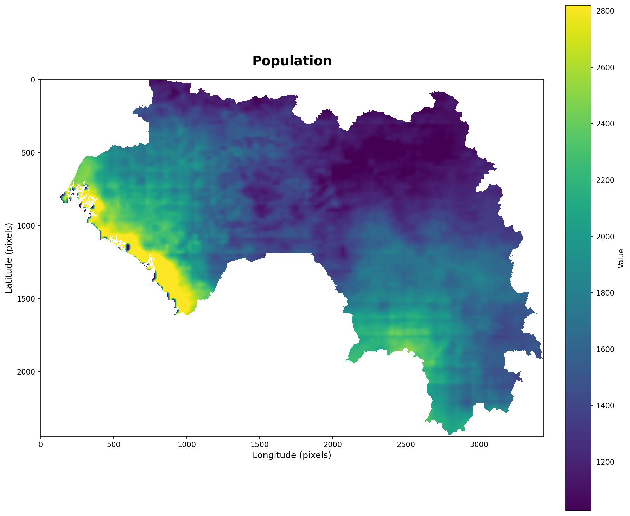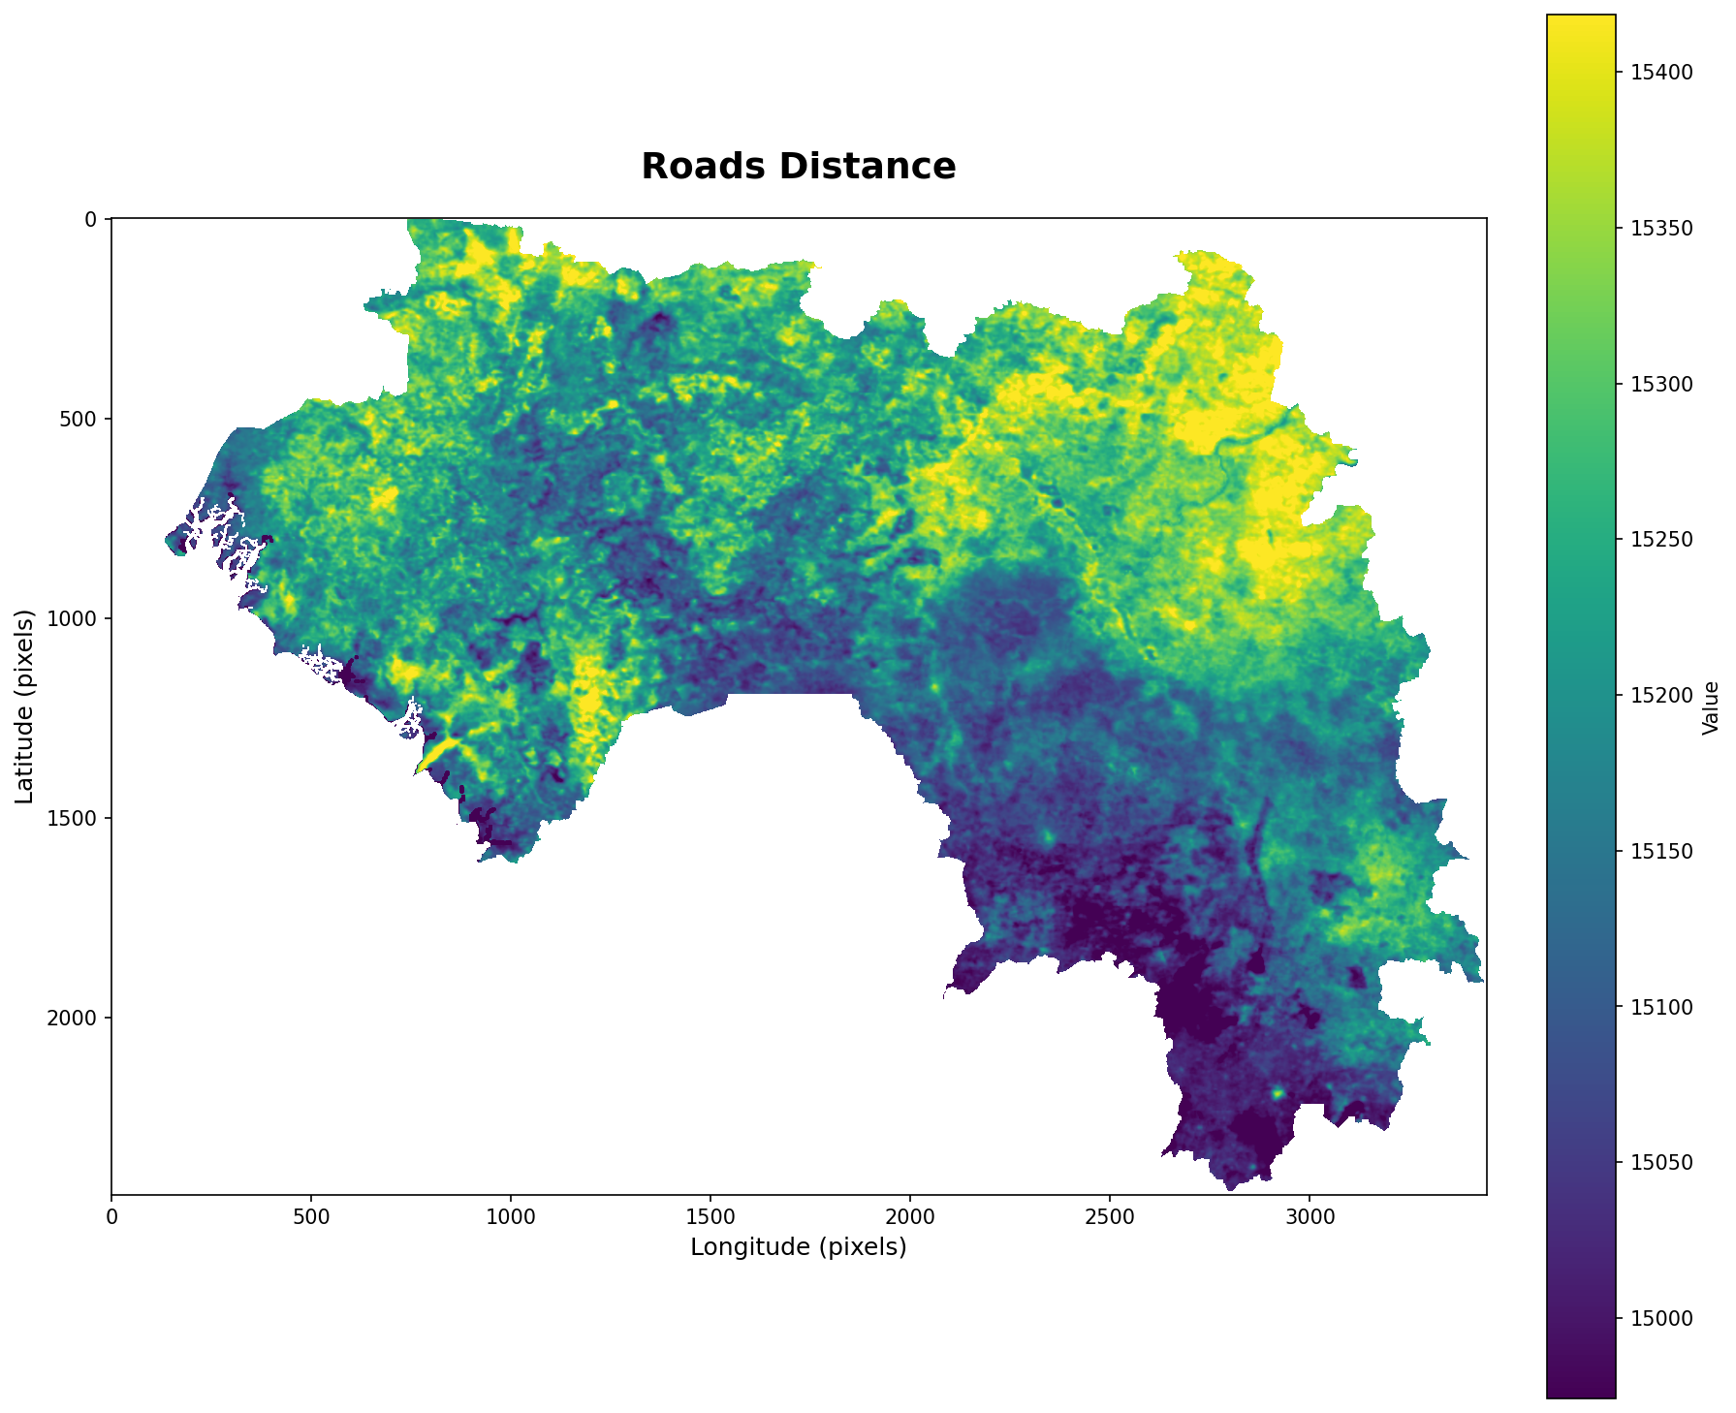
Figure 2 (left). Population density map of Guinea from WorldPop. Figure 3 (right). Road distance map of Guinea derived from Geofabrik roads data.

5. Methodology

5.1 Preprocessing and Grid Alignment
All layers are reprojected and resampled onto a single analysis grid (250 m, EPSG:4326 / WGS 84), clipped to the Guinea boundary. Categorical layers use nearest-neighbour resampling; continuous layers use bilinear. Missing values are handled per layer type (imputation/exclusion for predictors, retained for targets, zero for proximity surfaces). All area-based (hectare) figures throughout this report are computed after clipping every input raster to Guinea's actual national administrative boundary (the country polygon, not its bounding rectangle). Ranking-based accuracy metrics (AUC, Figure of Merit, per-class accuracy) are unaffected by this, since they measure relative predictive skill within a consistently-defined pixel set, not absolute area.
250 m was used for this run to keep national-scale fetching, alignment and modelling tractable within the platform's country-scale export and runtime limits. It is a compromise: it coarsens the native 10 m LULC products (introducing mixed pixels, see Section 8) while over-resolving the 500 m–5.5 km climate and population predictors (introducing artificial spatial precision, see Section 8). The platform default is 100 m; 250 m was chosen here specifically to complete the full country-scale run.
Configuration used for this run. To keep the country-scale analysis tractable, this analysis enabled a single LULC product (ESRI/Impact Observatory) and used Google Earth Engine's SRTM-derived DEM in place of the OpenTopography source. This analysis also enabled the OpenStreetMap/Geofabrik vector predictors (roads, railways, waterways, points of interest), rasterized as Euclidean distance-to and kernel-density surfaces (see Section 4.4); the biomass (GEDI/AGB) layers remain disabled owing to country-scale size limits. The predictor set used was therefore ten raster and vector-derived surfaces — elevation, slope, aspect, population density, annual precipitation, land-surface temperature, distance to roads, distance to railways, distance to waterways and POI kernel density — plus soil moisture, a commodity-price surface (palm oil), with two additional forest-frontier surfaces (distance to forest edge, distance to prior loss) added for the deforestation driver model, for 13 predictors in total (see Section 5.7). Both models are validated by true temporal hold-out as standard practice: the land-cover transition/allocation model is calibrated on one pair of epochs and its prediction compared against a later, observed and unseen epoch, rather than calibrating and testing on the same interval; the deforestation risk model is calibrated on Hansen loss up to a given year and evaluated against loss observed in a later, unseen period (see Sections 6.3 and 7.7). This configuration — full predictor plus true temporal hold-out — is the standard setup used throughout this report.

5.2 Land-Cover Change Analysis
Transitions between epochs are quantified with a cross-tabulation (Markov) transition matrix, giving the number of pixels moving from each class to each class. Future demand is projected by extrapolating the observed transition rates (linear where ≥ 2 epochs, non-linear where more epochs allow). With four epochs available (2018, 2020, 2022, 2024), non-linear trend fitting is engaged for demand projection. The headline transition matrix (Table 1) reports the directly observed 2022→2024 comparison rather than the multi-period fitted output: the fitted aggregate was found to imply a net direction inconsistent with the raw data at every individual epoch pair and with the independently-measured Hansen record (Section 7.2), while the raw comparison is not subject to that inconsistency. This affects only the transition-matrix display in Table 1; it does not affect the deforestation risk model's future-demand projections (Section 7.8), which use a separate calculation based on the Hansen loss record directly.

5.3 Transition Suitability Modelling
For each modelled transition (≥ 200 pixels, the minimum-sample threshold), a Random Forest classifier (Breiman, 2001) is trained to distinguish pixels that underwent the transition from those that did not, using the aligned predictor stack. Random Forest is used because it handles non-linear relationships and correlated predictors without distributional assumptions, and its variable importances provide interpretable driver attribution. 28 transitions met the minimum-sample threshold and were modelled. Sampling is balanced per class to avoid the model trivially predicting persistence. Model outputs are per-pixel transition probabilities, forming a suitability atlas.

5.4 Allocation and Simulation
Projected demand (Section 5.2) is allocated to the pixels with the highest suitability, producing a simulated future land-cover map (Figure 8). Allocation may be deterministic (highest suitability first) or stochastic (weighted by suitability, for uncertainty envelopes); the deterministic variant was used here.

5.5 Forest Definition and Extent
Forest is defined as canopy cover ≥ 30% in the Hansen treecover2000 layer (the Global Forest Watch reporting default; sensitivity at 10%, 30%, and 50% is tested directly in Section 7.10). Forest extent in year Y is forest(Y) = forest(2000) AND NOT (loss occurred on or before Y). Hansen gain covers 2000–2012 only and is therefore not added back annually. As for the threshold sensitivity, FAO uses 10% canopy cover whereas GFW (Global Forest Watch) commonly reports at 30%. Reported areas change materially with this choice, so the threshold is stated with every figure. This sensitivity has been tested directly (Section 6.10) at 10%, 30% and 50%, restricted to Guinea's national boundary: forest area on the 2000 treecover baseline ranges from 1.71 million ha (50%) to 23.52 million ha (10%), with cumulative loss to 2024 ranging from 22.2% to 31.7% of the respective baseline (see Section 7.2).

5.6 Deforestation and Degradation Detection
Annual forest loss is decoded directly from Hansen lossyear (primary). This analysis implemented transition-based deforestation observing forest at t1 and non-forest at t2 in the LULC products, which additionally identifies what the forest became. For forest degradation, a decline in NDVI within pixels that remained forest was observed, separating thinning/disturbance from outright clearing. Unsupervised cross-check was performed with K-means clustering of the annual feature stack, clusters labelled forest/non-forest by mean NDVI. This cross-check was used only as a heuristic cross-check.

5.7 Driver Attribution
Pixels deforested during the analysis window (positive class) are compared with pixels that remained forest (negative class) using a balanced Random Forest over the driver stack. The stack combines the ten raster and vector-derived predictors of Section 4.4, including the distance-to-roads, distance-to-railways, distance-to-waterways and POI-density surfaces, plus soil moisture, a commodity-price surface (palm oil, Section 7.5), and two additional forest-frontier surfaces: distance to prior forest loss (the deforestation frontier) and distance to forest edge. Variable importances give the ranked driver attribution over all 13 predictors, and the fitted model produces a continuous deforestation risk map over standing forest (Figure 6).

5.8 Scenario Simulation
Future forest loss is projected by extrapolating historical loss (mean rate, linear trend, or constant percentage of standing forest) and allocated to the highest-risk forest pixels. Policy levers available: protected areas (risk set to zero), new road/frontier development (risk raised by proximity), and a governance factor scaling total demand. Business-as-usual, accelerated-frontier, and protected-area enforcement projections to 2025–2027 were all produced in this analysis (Section 7.8).

5.9 Implementation Approach
The analysis is implemented as two Python packages (landuse_tool and its deforestation_tool subpackage) rather than through an existing land-change modelling application. As the methods above could be misread, the position is stated explicitly here.
At the algorithm level, established reference implementations are used directly. Classification uses scikit-learn's RandomForestClassifier, the standard implementation of Breiman (2001); blocked cross-validation uses scikit-learn's GroupKFold; raster handling uses rasterio and GDAL; and Google Earth Engine (Gorelick et al., 2017) is used as a data-access layer. No machine-learning algorithm is reimplemented in this work.
At the orchestration level, the code is original: demand projection, the allocation routine, the forest-extent and loss decoding, and the validation harness are written for this project. They implement published methods, but they are this project’s implementation of those methods. This report does not claim to have run DINAMICA EGO, CLUE-S, Land Change Modeler, UDef-ARP or forestatrisk, and no result presented here is an output of those tools.
Reimplementation was necessary, for four reasons. First, coverage: forestatrisk models deforestation risk only and does not provide multi-class land-cover transition simulation or scenario allocation, so it addresses roughly one component of one module. Second, deployment architecture: DINAMICA EGO and Land Use Modeler are desktop GIS applications that cannot be invoked from a server-side pipeline behind a web API. Third, licensing: Land Change Modeler is distributed with the proprietary TerrSet package under per-seat licensing, which is incompatible with an open-source deliverable transferred to a national government. Fourth, data ingestion: CLUE-S and its relatives require locally prepared input rasters, whereas the platform requirement is live ingestion for any user-selected country and time window without hand-downloaded files. None of these tools could have been deployed as the web platform this analysis supports.
Independent implementations carry an obligation to demonstrate that they reproduce established results. To that end the adopted risk was cross-checked against forestatrisk (Vieilledent, 2021), the closest open-source analogue, fitted to the same calibration sample and scored on the same temporal hold-out. Results are reported in Section 7.7. The purpose of that comparison is corroboration of the implementation, not a ranking of models.

6. Validation and Accuracy Assessment

6.1 Why standard accuracy is not enough
In a change-modelling context, overall accuracy is dominated by pixels that did not change. A model that predicts "no change everywhere" typically achieves high overall accuracy while providing no information. This report therefore uses metrics designed for land-change assessment.

6.2 Reported Metrics
- Overall, user's and producer's accuracy from the confusion matrix of simulated versus observed land cover.
- Quantity and allocation disagreement (Pontius & Millones, 2011): Total disagreement decomposed into quantity (wrong amount of each class) and allocation (right amount, wrong location). The Kappa family is argued to be uninformative for simulated-versus-observed map comparison specifically and is therefore not used for that purpose here; this is distinct from using Cohen's kappa to measure agreement between two independent data products (Hansen and ESRI, Section 7.9), which is a different comparison and not subject to the same critique.
- Figure of Merit (Pontius et al., 2008): FoM = hits / (hits + misses + false alarms + wrong hits), comparing predicted change against observed change, ranging 0–100 %. In a comparison of 13 applications of 9 land-change models, error exceeded correctly predicted change in 12 of 13 cases, so modest FoM values are the norm.
- Null-model comparison: The accuracy of assuming pure persistence by relabeling the earlier map as the prediction for the later date, i.e. assuming no change occurs anywhere (Pontius & Malanson, 2005); the model must exceed this on overall accuracy to demonstrate value by that criterion; on short, low-change test windows this baseline is very high, and an allocation model that commits to the full observed change demand can fall below it even when its change predictions carry real skill, which is why the Figure of Merit (scored on change pixels only) is treated as the primary hold-out skill metric for the land-cover component (Section 7.7). It is computed directly from this dataset (how much of the landscape is genuinely stable between the two dates), not an externally chosen threshold.
- Spatial block cross-validation (Roberts et al., 2017): Neighboring pixels are spatially autocorrelated, so a random split places near-duplicate samples on both sides and underestimates predictive error. We report accuracy under spatially blocked CV, plus the random-split figure and the gap between them (the optimism gap).
- ROC-AUC of the risk map: Whether the deforestation risk surface ranks pixels actually lost above those that survived, over standing forest only.
- Area estimation with confidence intervals (Olofsson et al., 2014): Where reference sample data are available, mapped areas are adjusted for classification error and reported with a 95 % CI. No reference sample was available in this run (see Section 8).

6.3 Validation Design
- Temporal hold-out. Calibrate on an earlier interval and validate the prediction against the observed later map; this is the only test of genuine predictive skill, since metrics on the calibration interval are optimistic. Three land-cover hold-out splits were run (2018→2020 tested against observed 2022; 2020→2022 tested against observed 2024; and a longer-horizon split, 2018→2020 tested against observed 2024, with change demand scaled linearly to the 4-year window). Each land-cover split was additionally run in two configurations — the standard single-model design and an expander/patcher growth-mode variant with per-class neighbourhood-density predictors; results agreed within ±1.1 Figure-of-Merit points on every split, and the simpler standard configuration is adopted. Three independent historical splits were run for the deforestation risk model (calibrating on Hansen loss up to a given year, tested against loss observed in a later, unseen period). Results are reported in Chapter 7.
- Spatial hold-out. The study area is partitioned into 17 contiguous spatial blocks (~654-pixel edge length) using a regular grid; 5-fold cross-validation is then run holding out whole blocks rather than individual pixels, so training and test samples are never spatially adjacent. Comparing this to a random (pixel-level) split isolates the inflation caused by spatial autocorrelation — nearby pixels sharing similar predictor values and outcomes purely due to proximity (Roberts et al., 2017) — and is the standard remedy for it in spatial machine learning. Results are reported in Chapter 7.
- Reference data: No independent ground or reference data were used. All accuracy figures are therefore product-to-product or internal cross-validation, not independent validation.

7. Results

7.1 Land-Cover Change
Table 7. Transition matrix, 2022→2024 (pixels; 1 px ≈ 6.25 ha at 250 m). Shaded diagonal = persistence (no change). Off-diagonal = conversions.
From \ To | Water (1) | Trees (2) | Flooded (4) | Crops (5) | Built (7) | Bare (8) | Rangeland (11)
Water (1) | 200,653 | 918 | 577 | 109 | 23 | 350 | 1,766
Trees (2) | 1,017 | 3,607,038 | 2,367 | 4,755 | 2,290 | 5 | 378,725
Flooded (4) | 609 | 2,850 | 49,744 | 337 | 35 | 6 | 2,098
Crops (5) | 105 | 3,462 | 876 | 41,452 | 436 | 8 | 15,463
Built (7) | 25 | 1,772 | 57 | 231 | 71,078 | 15 | 6,199
Bare (8) | 260 | 2 | 12 | 12 | 7 | 809 | 134
Rangeland (11) | 748 | 303,313 | 2,154 | 26,559 | 5,963 | 46 | 2,320,209
The matrix is dominated by two large flows between the Trees and Rangeland classes: 378,725 pixels of Trees converted to Rangeland, and 303,313 pixels of Rangeland converted to Trees, 2022–2024 — 97.3% of all Trees pixels that changed class became Rangeland, consistent across every epoch pair tested in this analysis. At the 250 m grid these correspond to roughly 2.37 million ha and 1.90 million ha, a net conversion of about 471,000 ha of Trees to Rangeland over these two years alone. All other transitions are at least an order of magnitude smaller, and the persistence terms are large (Trees 3,607,038 px; Rangeland 2,320,209 px), so most of the landscape is stable between the two dates. This table uses the raw, directly-observed 2022→2024 comparison rather than the multi-period non-linear-fitted matrix: the fitted aggregate was found to imply a net gain in forest (Rangeland→Trees exceeding Trees→Rangeland in absolute terms) that contradicts the Hansen record and every raw single-period comparison tested — a likely artifact of the non-linear fitting procedure across periods with different underlying rates, not a real reversal in land-cover dynamics. The raw pairwise matrix shown here is not subject to that artifact. Class code 10 ("Clouds" in ESRI's scheme, a no-data/cloud-masking code rather than a real land-cover class) is excluded from this table; it appears at negligible volume in the source data. The large two-way Trees↔Rangeland exchange is characteristic of classification instability between wooded and open-vegetation classes in a savanna–forest mosaic at coarse resolution; part of the gross flow should be read as label noise rather than physical conversion (see Section 7).

7.2 Forest Cover and Loss
Table 8. Forest cover and annual loss (Hansen canopy definition, ≥ 30 %).
Year | Forest (ha) | Annual loss (ha) | Decline (%/yr)
2018 | 5,464,804 | — (baseline) | —
2019 | 4,944,635 | 520,169 | 9.52
2020 | 4,445,306 | 499,329 | 10.10
2021 | 3,975,667 | 469,639 | 10.56
2022 | 3,604,681 | 370,986 | 9.33
2023 | 3,172,493 | 432,188 | 11.99
2024 | 2,723,699 | 448,794 | 14.15
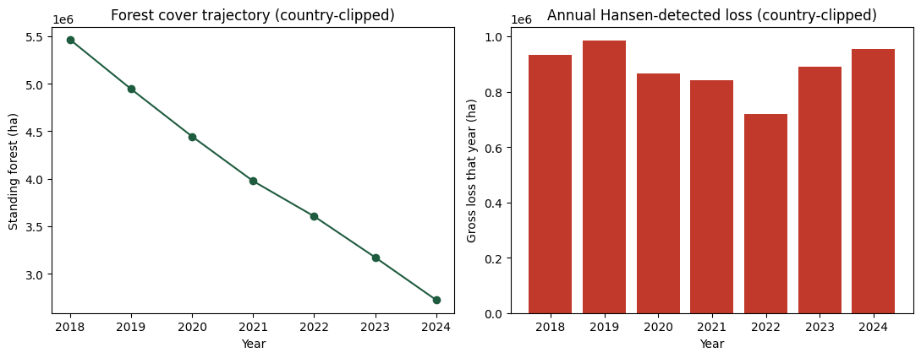
Figure 3. Forest cover trajectory (left) and annual forest loss (right), 2018–2024, from the Hansen canopy-loss record.
Standing forest area (Hansen canopy definition), restricted to Guinea’s actual national boundary throughout, declined from 5.46 million ha in 2018 to 2.72 million ha in 2024 — a net decline of 50.2% over six years, compound rate 10.96% per year. Cumulative Hansen-detected loss within the 30% canopy mask over 2019–2024 is 2.74 million ha. Under the forest definition used here (Section 5.5), where Hansen gain is not added back, cumulative loss and net extent decline are the same quantity and must agree exactly; they do, and the figure is confirmed independently by the canopy-threshold computation is Section 7.10 (2,741,104 ha). The administrative-zone breakdown is reported on the unthresholded loss mask and is therefore not directly comparable to this table; see the note in Section 7.6.
The Hansen canopy definition at a 250 m grid still includes savanna woodland and tree-crop/plantation systems that are not forest in the sense this report’s land-cover classes use (Section 1.1), and coarsening the 30 m Hansen product to 250 m still introduces some additional inflation from mixed pixels; both effects are real but modest relative to the totals reported here. The gap between the Hansen and ESRI lenses is quantified directly in Section 6.9: pixel-level agreement 54.7%, Cohen’s kappa 0.097 — “slight” agreement, near the lower bound of that category. Most Hansen-flagged disturbance is not accompanied by an ESRI-registered land-cover class change (Section 7.3), confirmed across three independent comparison windows rather than one — a genuine characteristic of how these two products relate in this landscape, not an artifact of any single test.
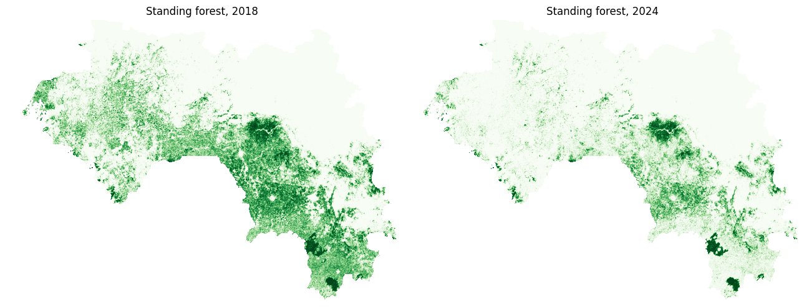
Figure 4. Standing forest maps in 2018 (left) and 2024 (right).
The constancy of the annual rate between 2023 and 2024 show a materially higher year-on-year decline (12.0% and 14.2%) than 2019–2022 (9.3–9.5%), consistent with a shrinking forest base experiencing a broadly similar absolute rate of clearing — a mechanically expected pattern as the denominator shrinks, not necessarily evidence of an accelerating underlying process. Individual year-to-year figures still carry more noise than any single number implies, since Hansen’s lossyear attribution can be off by roughly ±1 year for a given pixel (cloud cover and imagery gaps can shift which year a loss event registers in); the multi-year average remains less sensitive to this than any single year’s figure.

7.3 Forest Conversion
Table 9. What standing forest became, 2018-2024 (Hansen forest ∩ ESRI land cover).
To class | To name | Pixels
2 | Trees | 342,848
11 | Rangeland | 92,099
7 | Built Area | 1,219
5 | Crops | 908
4 | Flooded Vegetation | 743
1 | Water | 583
8 | Bare Ground | 1
Of pixels Hansen flagged as deforested between 2018 and 2024, the majority (342,848 of 438,401, 78.2%) are still classified as Trees by ESRI at the end of the window, not converted to any other class. Rangeland is the largest actual conversion (92,099 pixels, 21.0%); Built Area, Crops, Flooded Vegetation and Water are minor by comparison, and Bare Ground is negligible. This is exact, computed directly, and confirmed via three independent comparison windows (2018→2022, 2018→2024, and the shortest available raw comparison, 2020→2022) — all three show Trees, not Rangeland, as the dominant outcome, ruling out both a window-length artifact and an anchor-year artifact. This means most Hansen-detected canopy disturbance in this dataset is not accompanied by a class change ESRI's classifier registers at all — the clearest, most concrete illustration in this report of the general point made in Section 8(a): canopy disturbance and land-cover class change are related but distinct signals, and the gap between them is a directly measured, three-times-confirmed characteristic of how these two products relate in Guinea, not an assumption or a single-test result.

7.4 Deforestation Drivers
Table 10. Driver importance (Random Forest, forest loss vs standing forest).
Driver | Importance
Distance to forest edge | 0.621
Land-surface temperature | 0.093
Distance to prior loss | 0.070
Commodity price (palm oil) | 0.041
Distance to railways | 0.031
Distance to roads | 0.023
Elevation | 0.022
Population density | 0.021
Soil moisture | 0.020
Precipitation | 0.020
Slope | 0.013
POI kernel density | 0.010
Distance to waterways | 0.008
Aspect | 0.007
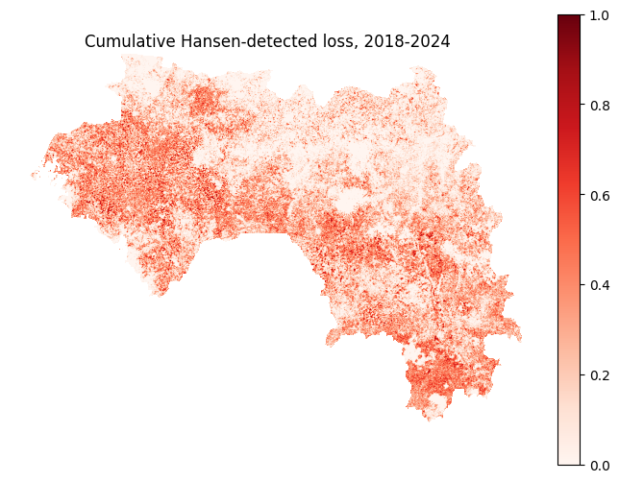
Figure 5. Cumulative detected loss map.
Distance to forest edge is by far the strongest spatial correlate of forest loss (importance 0.62), followed at a considerable distance by land-surface temperature (0.09) and distance to prior loss (0.07). The adopted commodity-price predictor ranks fourth (0.04), ahead of every other predictor besides these three. Distance to railways (0.03), distance to roads (0.02), elevation (0.02), population density (0.02), soil moisture (0.02) and precipitation (0.02) form the middle tier of modest, comparable contributors; slope (0.01), POI kernel density (0.01), distance to waterways (0.01), and aspect (0.01) are the smallest. The pattern remains edge- and frontier-driven: forest is lost at the margins of existing forest and near areas of previous loss, rather than in proportion to population, accessibility, or terrain, consistent with an expanding-frontier / mosaic-clearing process.
Two cautions apply. First, the dominance of distance-to-edge is partly mechanical — forest can only be lost where a forest edge exists — so its high importance is expected and does not by itself demonstrate a strong environmental control. Second, importances describe association, not causation (see Section 5.7 and 7). This analysis enabled the OSM/Geofabrik road, railway, waterway and POI predictors and their measured importance is consistently low (each ≤ 0.03); this provides direct evidence that accessibility and point-of-interest proximity are not strong statistical correlates of forest loss in this dataset, though it remains an association-only result, and OSM road/rail completeness in Guinea is itself uneven, which could attenuate their apparent effect.
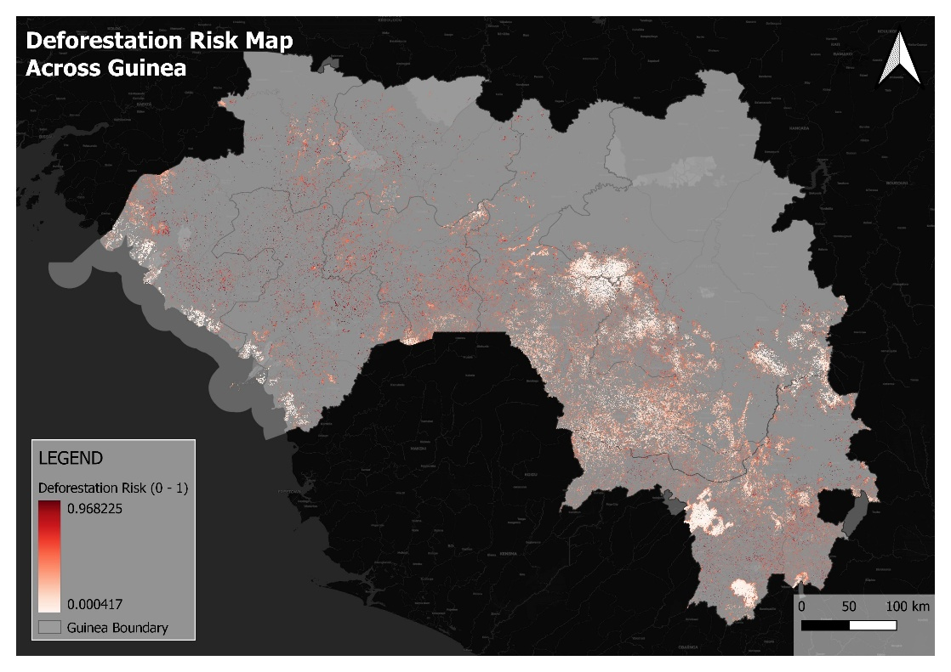
Figure 6. Deforestation risk map — modelled probability of loss for each standing-forest pixel (fitted driver model applied to standing forest).

7.5 Candidate Predictors
NDVI and Burned Areas layers were tested by adding them to the adopted (dist_forest_edge-excluded) risk-model configuration and re-running the same 2015-2018→2019-2022 hold-out, using a pre-disturbance baseline (earliest available year, not a same-window value) specifically to avoid re-encoding the frontier-proximity problem dist_forest_edge had. Both are rejected. NDVI (pre-disturbance 2018 baseline): calibration CV 0.925, true hold-out AUC 0.479 — below chance, far below the adopted baseline. Burned area (cumulative frequency through 2018): calibration CV 0.924, true hold-out AUC 0.496 — the same pattern. In both cases the large gap between near-perfect same-window fit and below-chance hold-out mirrors dist_forest_edge's own signature: despite the pre-disturbance-baseline mitigation, both predictors still spatially concentrate around wherever recent disturbance already occurred, encoding frontier proximity rather than an independent risk signal. A night-time-lights (VIIRS) predictor was evaluated under the same protocol as well and showed no decisive benefit (an improvement of 0.0008 on a single split, within run-to-run noise). None of these candidates is included in the adopted configuration.
A commodity-price predictor (palm oil, an internationally traded commodity for which price fluctuations are a well-documented direct driver of tropical deforestation) is included in the adopted risk model, using WFP market-price data interpolated to a continuous surface. Validated via the same protocol as every other candidate predictor, this predictor improves AUC on every split (0.6891→0.6986, 0.6600→0.6659, 0.5642→0.5680) and is fetched and rasterized automatically as part of the standard analysis pipeline. In the full adopted configuration, it ranks fourth by importance (0.041), and the model's overall calibration accuracy is 0.762. Four candidates tested through this protocol to date, one adopted, three rejected — the discipline of requiring improvement on every historical split, not just one, is what distinguishes the outcomes.

7.6 Administrative Zone Breakdown
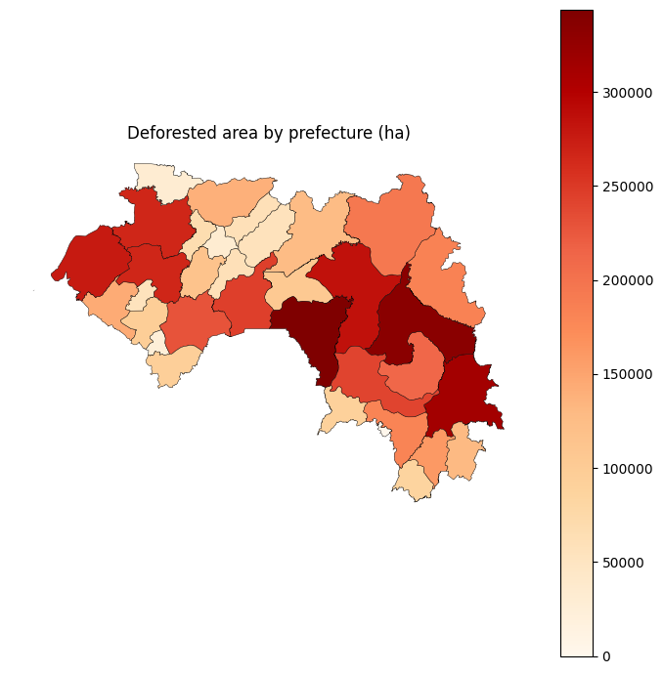
Figure 7. Zonal choropleth of deforested area by prefecture.
Deforested area (Hansen loss_window_mask, 2018-2024) was summarised per prefecture (admin_level6, Geofabrik OSM administrative-areas extract — chosen because, unlike the raw extract’s mixed national/regional/prefecture/sub-prefecture polygons, it does not double-count the same land area at nested levels), giving regional offices a figure specific to their area of responsibility. The five highest-loss prefectures are Faranah (343,810 ha), Kankan (333,470 ha), Beyla (313,904 ha), Kouroussa (285,474 ha) and Boké (277,648 ha); the sum across all 34 prefectures (5,255,377 ha) matches the gross Hansen loss figure in Section 7.2, computed on the same unthresholded loss mask, to within 0.01%. That agreement confirms the zonal code path, not the canopy threshold: both figure are evaluated without the 30% mask and are thereforelarger than the thresholded totals in Section 7.2. The prefecture ranking is unaffected, but the absolute hectare figures in this section should be read as unthresholded (Section 9).

7.7 Model Accuracy
Table 11. Per-class accuracy (simulated vs observed 2022 land cover). Background / no-data pixels (n = 1,356,994) are excluded; they are trivially matched.
Class | User's acc. | Producer's acc. | F1 | N reference
Water | 0.993 | 0.999 | 0.996 | 204,396
Trees | 0.976 | 0.970 | 0.973 | 3,996,213
Flooded vegetation | 0.970 | 0.981 | 0.975 | 55,679
Crops | 0.890 | 0.885 | 0.888 | 61,802
Built | 0.946 | 0.986 | 0.965 | 79,377
Bare | 1.000 | 1.000 | 1.000 | 1,236
Rangeland | 0.954 | 0.961 | 0.958 | 2,658,995
All classes reproduce well (F1 ≥ 0.95) except Crops (F1 0.89), which is the most spectrally variable class and most easily confused with Rangeland. The two dominant classes, Trees (F1 0.97) and Rangeland (F1 0.96), are both reproduced accurately.
Within its own calibration window — a same-window metric, reported here as context, not as the validated result (see below) — the land-cover model achieves overall accuracy of 97.2%, Figure of Merit of 78.9%, and total disagreement of 0.0276 (dominated by allocation, 0.0245, rather than quantity, 0.0030): the amount of change is projected almost exactly, with residual error concentrated in the precise placement of change. Same-window metrics are systematically optimistic, since the model is evaluated on data it has already seen; they are not treated as evidence of forward predictive skill in this report.
Table 12. Change-model accuracy summary.
Metric | Value
Overall accuracy | 0.972 (97.2 %)
Null-model (persistence) accuracy | 88.91 %
Figure of Merit | 78.87 %
Quantity disagreement | 0.0030
Allocation disagreement | 0.0245
Total disagreement | 0.0276
Spatial CV accuracy (change/no-change) | 0.548 ± 0.039
Random CV accuracy | 0.601 ± 0.013
Optimism gap (random − spatial) | 0.0536
Deforestation risk model CV accuracy (same-window, dist_forest_edge included) | 0.960 ± 0.002 (n = 10,000) — flagged as optimistic, see caution below
Risk-map AUC (back-test, same window) | 0.994 (n = 777,108 — same-window back-test, see caution below and Section 6.3)
Adopted risk model CV accuracy (dist_forest_edge excluded, commodity price included) | 0.762
Risk-map AUC (TRUE temporal hold-out, adopted configuration) | 0.564–0.689 across 3 historical splits; most recent/policy-relevant split 0.689 (Section 7.7)
Land-cover TRUE temporal hold-out FoM (three splits) | 15.91% / 15.59% (2-year splits); 20.80% (4-year horizon)
Land-cover TRUE temporal hold-out overall accuracy | 91.10% / 91.13% / 86.79% — below the persistence baselines (93.96% / 93.78% / 92.27%); expected for allocation models on low-change windows (see narrative below)
The deforestation risk model shows the same pattern more starkly: same-window CV accuracy of 0.960 and a same-window risk-map AUC of 0.994 both collapse under true out-of-sample testing (below), confirming that same-window metrics alone would have substantially overstated both models' real-world skill.
The standard this report treats as authoritative is the true temporal hold-out — calibrating on one period and testing against a later, genuinely unseen one, not the same interval used for calibration. For the land-cover model, three splits were run (2018→2020 tested against observed 2022; 2020→2022 tested against observed 2024; and a longer-horizon split, 2018→2020 tested against observed 2024). Figure of Merit is 15.91% and 15.59% on the two 2-year splits and 20.80% on the 4-year split — modest but genuine change-prediction skill that scales with the amount of observed change in the test window, exactly as the FoM literature predicts (Pontius et al., 2008; in that 13-application comparison, error exceeded correctly predicted change in 12 of 13 cases). Hold-out overall accuracy is 91.10%, 91.13% and 86.79% against persistence baselines of 93.96%, 93.78% and 92.27%: the model does not beat pure persistence on overall accuracy. This is an expected property rather than a defect — with only a few percent of pixels changing per 2-year window, relabelling the start map is already a ~94%-accurate “prediction” by construction, and an allocation model that commits to the full observed change demand pays an accuracy cost for every mislocated change pixel — so the Figure of Merit, scored on change pixels only, is the authoritative skill metric for this component, and FoM and overall accuracy are not directly comparable since they are scored differently. Each split was additionally run in an expander/patcher growth-mode configuration with per-class neighbourhood-density predictors; results agreed with the standard configuration within ±1.1 FoM points on every split, so the simpler standard configuration is adopted.
The adopted deforestation risk model excludes distance-to-forest-edge from its predictor stack: this variable encodes each calibration period's specific forest-frontier geometry rather than a transferable spatial risk pattern, so its inclusion would tie the model to the exact frontier shape of its training period rather than to features that generalize forward; it is retained only for descriptive attribution (Table 7), not for prediction. True temporal hold-out validation confirms this configuration performs consistently above chance across three independent historical splits: AUC 0.564, 0.660, and 0.689, with the most recent and most policy-relevant split (calibration 2015–2018, tested against 2019–2022) at 0.689. This is a legitimate basis for cautious spatial screening and prioritisation, not a guarantee of any individual location's outcome.
The headline honest accuracy is the spatially blocked cross-validation figure for the change/no-change classifier: 54.8 % (± 3.9 %) on a balanced (50/50) sample. The random-split figure (60.1 % ± 1.3 %) is 5.4 points higher; this optimism gap is the amount by which a naive random split would have overstated pixel-level skill. Adding the four vector-derived accessibility predictors (roads, railways, waterways, POI density) to the driver/predictor stack did not improve — and if anything slightly widened — this gap relative to the six-raster-predictor configuration (previously 2.8 points), and the spread across the five spatial folds is also wider (± 3.9 % vs ± 1.5 %), consistent with the new predictors adding little independent signal while the small number of large spatial blocks (17) keeps fold-to-fold variance high. The contrast between the strong map-level Figure of Merit and the modest spatially-independent skill is consistent with the disagreement decomposition: the model gets the totals right and captures the large, spatially coherent Trees↔Rangeland exchange in aggregate, but its pixel-level discrimination of exactly where change occurs is not as large. The small quantity disagreement confirms the demand projection is sound, while the larger allocation disagreement and modest spatial CV point to the suitability/driver model as the weaker link and the priority for improvement.

7.8 Future Scenarios
Figure 8 shows the simulated future land-cover map produced by the allocation step: transition models are calibrated on the most recent observed interval (2022→2024, the adopted standard configuration of Section 7.7), the observed transition demand is scaled linearly to the 2024→2027 horizon, and that demand is allocated to the pixels of highest modelled suitability over the observed 2024 baseline — a business-as-usual continuation of the most recent observed dynamics. The simulated map continues the dominant Trees↔Rangeland exchange: net simulated change 2024→2027 is −76,890 Trees pixels (≈ −480,600 ha) against +70,036 Rangeland pixels (≈ +437,700 ha), with Crops the next-largest gainer (+11,649 px, ≈ +72,800 ha). The implied ESRI-lens net Trees decline (~160,000 ha/yr) sits roughly five times below the Hansen-based projection below — the same lens discrepancy quantified in Sections 7.3 and 7.9, carried forward consistently into the scenarios: the two figures answer different questions (net class conversion versus gross canopy disturbance) and should not be compared directly or summed.
The deforestation pipeline additionally projected forest loss to 2025–2027 using the adopted risk configuration (Section 7.7, including the confirmed commodity-price predictor): business-as-usual projects 853,900 ha/year (2,561,700 ha total demand over the three years); an illustrative accelerated-frontier variant (1.5x the historical rate, one of several possible multipliers, not a prediction) projects 3,842,549 ha total demand.
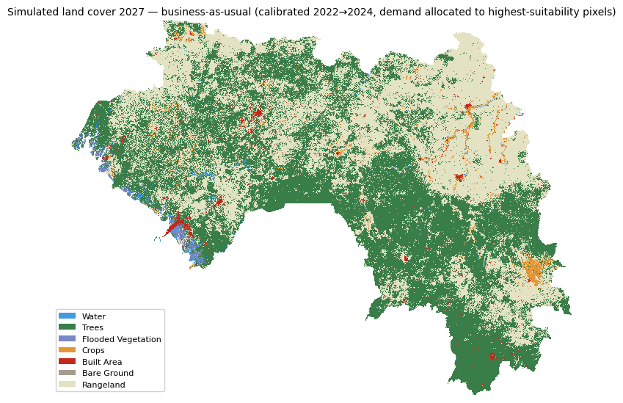
Figure 8. Simulated land cover under business-as-usual — projected class demand allocated to the highest-suitability pixels, calibrated 2022→2024, projected to 2027.
A protected-area variant (WDPA, 141 features covering 16.2% of Guinea's grid) was also run, and it surfaced a genuine, substantive finding rather than a simple confirmation that protection helps: business-as-usual allocates 720,398 ha of the projected clearing inside protected zones (the risk map does not avoid them on its own); the protected-area scenario, with clearing inside protected zones hard-excluded rather than merely deprioritized, allocates 0 ha there — but in doing so exhausts all available non-protected forest before reaching the full projected demand. Only 1,628,626 ha of the 2,561,700 ha demand can be accommodated outside protected zones; the remaining 933,074 ha (36.4% of projected demand) cannot be allocated at all under full protection enforcement, simply because there is not enough non-protected standing forest left to absorb it within the three-year window. This is a meaningful result in its own right: it indicates that at the historical rate this analysis extrapolates from, Guinea's current protected-area network, even if perfectly enforced, would not be sufficient on its own to contain projected demand — a finding that reinforces, with an actual number behind it, the caution already stated in this report that these projections are scenarios conditioned on historical continuation, not forecasts.

7.9 Data-Product Agreement (Hansen vs. ESRI)
Sections 7.1-7.3 note that Hansen and ESRI give different forest-loss magnitudes. To quantify this, pixel-level agreement, Cohen’s kappa, and a full breakdown were computed directly, restricted to Guinea’s actual national boundary. Pixel-level agreement is 54.70%, with Cohen’s kappa of 0.097 — “slight” agreement on the standard categorical scale (Landis & Koch, 1977), near the lower bound of that category. Of 454,216 pixels flagged as loss by either product, 380,039 are Hansen-only and 15,815 are ESRI-only, with 58,362 flagged by both — Hansen registers roughly 24x more standing-forest area as lost than ESRI does within the same universe, consistent with Hansen’s known tendency to register any canopy disturbance (including degradation and non-permanent loss) that a discrete land-cover classification does not. This is directly consistent with Section 7.3’s finding that most Hansen-flagged disturbance is not accompanied by an ESRI-registered class change — the same underlying phenomenon measured two different ways. The two products should continue to be reported side by side, each clearly labelled, rather than blended into one unlabeled figure.

7.10 Canopy-Threshold Sensitivity
Forest area and loss were recomputed at three standard canopy-cover thresholds over the full 2018–2024 window, restricted to Guinea’s national boundary. Extent here is the Hansen treecover2000 baseline, i.e. forest in 2000 before any loss is subtracted; it is therefore not the same quantity as the 2018 standing-forest figure in Section 7.2, and the two should not be compared directly. At 10% (FAO convention): 23.52 million ha forest in 2000, 5.22 million ha (22.2%) lost by 2024. At 30% (GFW default, used elsewhere in this report): 9.16 million ha forest in 2000, 2.74 million ha (29.9%) lost in over the 2018-2024 window – 29.9% of the 2000 baseline, though note that the loss window and the extent year differ, so this ration is not a like-for-like loss fraction — this loss figure matches the net-decline calculation in Section 7.2 to within rounding, an internal consistency check passed. At 50% (stricter): 1.71 million ha forest, 543,069 ha (31.7%) lost. This range should be reported wherever a single loss figure might otherwise be quoted.

7.11 External Benchmarking Against Global Nature Watch
Table 2. Observed forest change, this analysis against published reference figures.
Quantity | This analysis | Reference | Source
Tree cover extent, Guinea, 30% canopy (2000 baseline) | 9.16 million ha (2000 tree cover baseline, Section 7.10) | ~8.28 million ha (2000). | GNW/GFW Guinea country dashboard
Annual tree cover loss, Guinea, 30% canopy, 2019-2024 | 370,986 – 520,169 ha/yr (mean ~ 457,000; Table 5) | 128,000-187,000 ha/yr over 2019-2024 (annual bars, Guinea dashboard) | GNW/GFW Guinea country dashboard (>30% canopy, 2000 extent, gain not accounted for)
This comparison separates cleanly into agreement on one quantity and divergence on the other, and the separation is itself diagnostic. On extent, the two sources agree: 9.16 million ha on the 2000 Hansen baseline at the 30% threshold is 10.7% above the reference platform’s implied 8.28 million ha, a difference consistent with resampling a 30 m canopy layer onto a 250 m grid and thresholding the cell mean. On loss, they do not: cumulative loss over 2001–2024 computed here is 6.44 million ha, against 2.4 million ha reported for 2001–2025, a factor of 2.7; over the 2019–2024 window specifically the figures are 2.74 million ha against approximately 0.96 million ha, a factor of 2.9. Expressed as a share of the 2000 baseline, this analysis implies 70% of Guinea's tree cover was lost by 2024, whereas the reference platform reports 29% by 2025.
Two further points follow. First, the coincidence between the 29.9% figure quoted in Section 7.10 and the reference platform's 29% should not be read as agreement: the former is loss over 2018–2024 expressed against the 2000 baseline, the latter is loss over the full 2001–2025 record against the same baseline. They are different quantities that happen to produce a similar ratio, Section 7.10 states its windows explicitly. Second, because extent agrees to within 11% while loss diverges by a factor approaching three, the discrepancy cannot be attributed principally to the canopy mask or to the treecover resampling — those would inflate extent in the same proportion. It localizes instead to the decoding of the annual loss band onto the 250 m grid, which is a narrower and more tractable problem than a general resolution effect. Section 8 records this as outstanding reconciliation.
The reference platform additionally reports that humid primary forest accounts for only 0.81% of Guinea's tree cover loss over 2002–2025 (19 thousand ha, an 8.0% reduction in primary forest extent). This is independent confirmation of a point made throughout this report: the great majority of what the Hansen 30% canopy mask registers as forest in Guinea is savanna woodland and tree-crop or plantation systems rather than closed moist forest, and loss figures derived from that mask should not be read as primary-forest loss. It also gives a reason to treat the reference platform's own pre-2015 series with care: the dashboard carries an explicit advisory that a methods change causes tree cover loss in Guinea to be under-reported before 2015 and that figures either side of that break should not be compared. The 2019–2024 comparison used above falls entirely after the break and is unaffected.

8. Limitations and Uncertainty
- Canopy tree-cover loss is not the same as a land-cover class change. The Hansen product maps canopy disturbance, including plantation harvest, and does not distinguish natural forest from plantations (Tropek et al., 2014); it answers "was canopy lost here," not "what discrete cover class is this now." In this analysis the effect is directly visible and quantified: the Hansen canopy-loss lens indicates 2.74 million ha of loss within the 30% canopy mask over 2019–2024 (Section 7.2), whereas the ESRI land-cover transition registers a class change for only 21.8% of Hansen-flagged disturbed pixels (Section 7.3) — confirmed across three independent comparison windows, not a single test. The Hansen figure still includes canopy disturbance in Savanna Woodland and tree-crop/plantation systems that a land-cover classification would not count as forest to begin with. The two products answer related but distinct questions and are reported here as complementary, clearly labelled lenses rather than reconciled into one figure (Section 7.9).
- Land-cover products disagree, and the true magnitude of that disagreement is measured over the full four-epoch window. Independent comparison of the 10 m global products shows substantial disagreement in general (Venter et al., 2022). Here this manifests as the large two-way Trees↔Rangeland exchange in the transition matrix (Section 7.1) and as a directly quantified gap between the Hansen and ESRI forest-loss signals (Section 7.9: pixel agreement 54.7%, kappa 0.097 — “slight” agreement, near the lower bound of that category) and, more concretely, in Section 7.3’s finding that 78.2% of Hansen-flagged disturbed pixels are still classified as Trees by ESRI, confirmed across three independent comparison windows. This is a substantial and well-characterized source of uncertainty.
- Absolute area figures are over-estimated and should not be quoted externally until recomputed. External benchmarking (Section 7.11) shows forest extent agreeing with the reference platform to within 10.7% on the 2000 baseline, while cumulative loss diverges by a factor of 2.7 and annual loss over 2019–2024 by a factor of 2.9. Because extent agrees while loss does not, the cause is localised to the decoding of the annual loss band onto the 250 m analysis grid rather than to the forest definition, the canopy threshold, or the Hansen product. Ranking-based metrics (AUC, Figure of Merit, per-class accuracy) and the product-agreement results in Sections 7.3 and 7.9 are unaffected, since they compare relative skill and masks rather than areas. Recomputation and re-benchmarking is the highest-priority outstanding action arising from this analysis.
- Dry versus moist forest. A single canopy threshold is a compromise across Guinea’s moisture gradient. According to the sensitivity test, the choice is shown to materially change both the forest baseline (1.71–23.52 million ha) and the loss fraction (22.2-31.7%). The 30 % (GFW) threshold is used elsewhere in this report; any figure quoted outside this range of thresholds should state which was used.
- Mixed resolutions. Predictors span 10 m to ~5.5 km. The 250 m analysis grid used in this run was chosen specifically because of limited computation time and country-scale runtime constraints on the hardware available for this run, not because 250 m is the platform's intended default; it coarsens the 10 m LULC products (creating mixed pixels along every class boundary) and over-resolves the 500 m–5.5 km climate and population predictors. In the full platform, this constraint does not apply, and running at a finer resolution (the platform default is 100 m — Section 5.1) is expected to reduce the mixed-pixel effects contributing to the large Trees↔Rangeland exchange (Section 7.1).
- Spatial autocorrelation. Random cross-validation (CV) inflates apparent skill (Roberts et al., 2017). This is quantified here as the optimism gap, which widened from 2.8 points with six raster predictors to 5.4 points once the vector-derived accessibility predictors were added (see Section 7.7) — evidence that the extra predictors did not buy genuine spatial generalization, and even blocked CV cannot fully remove the effect.
- Association, not causation. Driver importances are correlational. Roads may follow clearing as much as preceding it, and distance-to-edge is partly a mechanical constraint (see Section 7.4). This run directly tested the road/rail/waterway/POI predictors and their importance is consistently low; this is informative but not conclusive, since OpenStreetMap road and rail completeness in Guinea is itself spatially uneven, and a variable that is poorly mapped will appear unimportant regardless of its true causal role.
- Projections are scenarios, not forecasts. Extrapolated rates assume continuity of the historical process; they exclude policy shocks, commodity prices and conflict (commodity price is already an adopted predictor in the risk model itself, but future price shocks are not projected). Business-as-usual, an accelerated-frontier variant (1.5x the historical rate), and a protected-area enforcement variant were all performed (Section 7.8).
- No independent field validation. No independent ground or reference data were collected or used. All accuracy figures are product-to-product or internal cross-validation — they measure the model’s ability to reproduce and predict the satellite-derived maps, not the maps’ agreement with conditions on the ground. Good practice for area estimation requires a probability sample of reference data (Olofsson et al., 2014); collecting one — together with the threshold and resolution sensitivity tests noted above — is a high-value next step.
- Both models were validated by true temporal hold-out, the standard this report treats as authoritative over same-window metrics. The land-cover model shows modest, genuine change-prediction skill on all three hold-out splits (Figure of Merit 15.6–20.8%, scaling with observed change; Section 7.7); its hold-out overall accuracy sits below the very high persistence baselines, as expected for allocation models on low-change windows, so the Figure of Merit is the authoritative metric for this component. The deforestation risk model's adopted configuration excludes distance-to-forest-edge, which was diagnosed as encoding period-specific frontier geometry rather than a transferable pattern; the adopted configuration achieves a hold-out AUC of 0.564–0.689 across three independent historical splits, confirmed stable (Section 7.7). Commodity price is an adopted predictor (Section 7.5), population is fetched per period rather than as a fixed snapshot, and slope/aspect/soil moisture are included in the current predictor set (Section 7.4). Remaining candidates for further predictor development include land-tenure proxies and mining permit/concession boundaries (data now available, pending testing — Section 9).

9. Conclusions and Recommendations
  - Guinea’s land-cover dynamics over 2018–2024 are dominated by exchange between wooded (Trees) and open-vegetation (Rangeland) classes, with a net loss of forest to rangeland. Conversion to rangeland/open vegetation is the dominant fate of cleared forest across both independent products used, making this the most robust single finding of the analysis.
  - The magnitude of forest loss is measured over the full six-year window (2018–2024, from direct annual Hansen observations — distinct from the non-linear trend fitting used for the land-cover model’s future demand projection, Section 5.2) and is well-characterized, though the two lenses disagree more than an intermediate version of this report stated: gross Hansen-detected loss within the 30% canopy mask is 2.74 million ha a 50.2% decline on the 2018 extent; the ESRI land-cover lens registers a class change for only a minority of that disturbed area (Section 7.3), with the majority remaining classified as Trees. Agreement between the two products is quantified directly (Section 6.9: kappa 0.097, "slight," near the lower bound of that category). No single loss figure should be reported without stating which product it comes from, the time window, and the threshold used (Section 7.10).
  - Forest loss is spatially edge- and frontier-driven: distance to forest edge and to prior loss are the strongest spatial correlates. With the road, railway, waterway and POI predictors enabled, population and accessibility are confirmed to have consistently modest importance — not strong drivers in this dataset — though this reflects statistical association within the current data and mapping completeness, not a causal test. This descriptive attribution (Table 10, Section 7.4) is computed with dist_forest_edge included, whereas the model adopted for forward risk prediction (Section 7.7) excludes it, since it was diagnosed as the specific cause of the original hold-out failure; the two configurations serve different purposes — association/attribution versus forward prediction — and should not be conflated. The adopted configuration's true temporal hold-out (Section 7.7) shows the risk model achieves a stable, above-chance AUC of 0.564–0.689 across three independent historical splits — usable for cautious spatial screening and prioritization.
  - The land-cover change/allocation model is validated by true temporal hold-out (calibrating on 2018→2020 and 2020→2022, tested against observed 2022 and 2024, plus a longer-horizon split tested against 2024), not same-window metrics. Figure of Merit is 15.91% and 15.59% on the 2-year splits and 20.80% over the 4-year horizon (Section 7.7) — modest, genuine change-prediction skill that scales with observed change as the literature predicts (Pontius et al., 2008). Hold-out overall accuracy (91.10%, 91.13% and 86.79%) does not exceed the persistence baselines (93.96%, 93.78% and 92.27%), an expected property of allocation models on low-change windows; the Figure of Merit, scored on change pixels only, is the authoritative metric for this component.
  - Recommendations for further model enhancement: (a) the risk model's roads/infrastructure predictor remains a single fixed-year snapshot; adopting the same per-period-fetch mechanism already used for population is a natural next step, pending an annual or near-annual roads data source; (b) the biomass (GEDI/AGB) predictors remain disabled due to a genuine country-scale export-size constraint; resolving this — either through a future data-processing improvement or a platform user supplying pre-tiled biomass data directly — would allow enabling them without further code changes; (c) a probability sample of reference data for Olofsson-style area estimation with confidence intervals has not yet been collected, and remains a recommended addition for rigorous accuracy reporting; (d) mining-distance as a risk-model predictor has not been tested — testing it through the same ablation and hold-out protocol used for every other adopted predictor is a reasonable next step; and (e) land-tenure proxies remain a candidate for future predictor development, pending an accessible data source.
Is this ready for nationwide platform deployment? With the qualifications below: yes, for both components, at their appropriate scope. The deforestation risk model, in its adopted and hold-out-validated configuration (Section 7.7, including the confirmed commodity-price predictor detailed in Section 7.5), is ready to support decision-making as a screening and prioritisation tool — provided it is presented to users with that scope explicitly stated (a risk ranking, not a guarantee; a scenario, not a forecast) and provided the sensitivity checks in Sections 7.7-7.9 are treated as part of the reported methodology, not as caveats set aside. The forward risk-scenario work (Section 7.8) also surfaced a substantive, reportable finding in its own right: at the historical rate this analysis extrapolates from, full enforcement of Guinea's current protected-area network would still leave 36.4% of projected demand unaccommodated — worth surfacing to decision-makers, not just as a model output.

10. References
Breiman, L. Random Forests. Machine Learning 45, 5–32 (2001). https://doi.org/10.1023/A:1010933404324.
Brown, C.F., Brumby, S.P., Guzder-Williams, B. et al. Dynamic World, Near real-time global 10 m land use land cover mapping. Sci Data 9, 251 (2022). https://doi.org/10.1038/s41597-022-01307-4
C. Vancutsem et al., Long-term (1990–2019) monitoring of forest cover changes in the humid tropics. Sci. Adv. 7, eabe1603 (2021). DOI:10.1126/sciadv.abe1603
Helmut J. Geist, Eric F. Lambin, Proximate Causes and Underlying Driving Forces of Tropical Deforestation: Tropical forests are disappearing as the result of many pressures, both local and regional, acting in various combinations in different geographical locations, BioScience, Volume 52, Issue 2, February 2002, Pages 143–150, https://doi.org/10.1641/0006-3568(2002)052[0143:PCAUDF]2.0.CO;2
Noel Gorelick, Matt Hancher, Mike Dixon, Simon Ilyushchenko, David Thau, Rebecca Moore. Google Earth Engine: Planetary-scale geospatial analysis for everyone. Remote Sensing of Environment. Volume 202. 2017. Pages 18-27. ISSN 0034-4257. https://doi.org/10.1016/j.rse.2017.06.031.
M. C. Hansen et al., High-Resolution Global Maps of 21st-Century Forest Cover Change. Science 342, 850-853 (2013). DOI:10.1126/science.1244693
K. Karra, C. Kontgis, Z. Statman-Weil, J. C. Mazzariello, M. Mathis and S. P. Brumby, "Global land use / land cover with Sentinel 2 and deep learning," 2021 IEEE International Geoscience and Remote Sensing Symposium IGARSS, Brussels, Belgium, 2021, pp. 4704-4707, doi: 10.1109/IGARSS47720.2021.9553499.
Pontius Olofsson, Giles M. Foody, Martin Herold, Stephen V. Stehman, Curtis E. Woodcock, Michael A. Wulder. Good practices for estimating area and assessing accuracy of land change. Remote Sensing of Environment. Volume 148. 2014. Pages 42-57. ISSN 0034-4257. https://doi.org/10.1016/j.rse.2014.02.015.
Pontius, R.G., Boersma, W., Castella, JC. et al. Comparing the input, output, and validation maps for several models of land change. Ann Reg Sci 42, 11–37 (2008). https://doi.org/10.1007/s00168-007-0138-2
Pontius, R. G., & Millones, M. (2011). Death to Kappa: birth of quantity disagreement and allocation disagreement for accuracy assessment. International Journal of Remote Sensing, 32(15), 4407–4429. https://doi.org/10.1080/01431161.2011.552923
Roberts, D. R., Bahn, V., Ciuti, S., Boyce, M. S., Elith, J., Guillera-Arroita, G., Hauenstein, S., Lahoz-Monfort, J. J., Schröder, B., Thuiller, W., Warton, D. I., Wintle, B. A., Hartig, F., & Dormann, C. F. (2017). Cross-validation strategies for data with temporal, spatial, hierarchical, or phylogenetic structure. *Ecography*, 40(8), 913–929. https://doi.org/10.1111/ecog.02881
Robert Tropek et al., Comment on “High-resolution global maps of 21st-century forest cover change”. Science 344, 981-981 (2014). DOI:10.1126/science.1248753
Venter, Z. S., Barton, D. N., Chakraborty, T., Simensen, T., & Singh, G. (2022). Global 10 m Land Use Land Cover Datasets: A Comparison of Dynamic World, World Cover and Esri Land Cover. Remote Sensing, 14(16), 4101. https://doi.org/10.3390/rs14164101
Landis, J. R., & Koch, G. G. (1977). The measurement of observer agreement for categorical data. Biometrics, 33(1), 159–174.
Pontius Jr, R. G., & Malanson, J. (2005). Comparison of the structure and accuracy of two land change models. International Journal of Geographical Information Science, 19(2), 243–265.
Liu, Z., Wimberly, M. C., & Dwomoh, F. K. (2017). Vegetation dynamics in the Upper Guinean forest region of West Africa from 2001 to 2015. Remote Sensing, 9(1), 5. https://doi.org/10.3390/rs9010005
Soares-Filho, B. S., Cerqueira, G. C., & Pennachin, C. L. (2002). DINAMICA — a stochastic cellular automata model designed to simulate the landscape dynamics in an Amazonian colonization frontier. Ecological Modelling, 154(3), 217–235. https://doi.org/10.1016/S0304-3800(02)00059-5
Verburg, P. H., Soepboer, W., Veldkamp, A., Limpiada, R., Espaldon, V., & Mastura, S. S. A. (2002). Modeling the spatial dynamics of regional land use: The CLUE-S model. Environmental Management, 30(3), 391–405. https://doi.org/10.1007/s00267-002-2630-x
Fitzgerald, M., Nackoney, J., Potapov, P., & Turubanova, S. (2021). Agriculture is the primary driver of tree cover loss across the Forestière region of the Republic of Guinea, Africa. Environmental Research Communications, 3(12), 121004.
Mas, J.-F., Kolb, M., Paegelow, M., Camacho Olmedo, M. T., & Houet, T. (2014). Inductive pattern-based land use/cover change models: A comparison of four software packages. Environmental Modelling & Software, 51, 94–111. https://doi.org/10.1016/j.envsoft.2013.09.010
Sims, M. J., Stanimirova, R., Raichuk, A., Neumann, M., Richter, J., Follett, F., MacCarthy, J., Lister, K., Randle, C., Sloat, L., Esipova, E., Jupiter, J., Stanton, C., Morris, D., Melhart Slay, C., Purves, D., & Harris, N. (2025). Global drivers of forest loss at 1 km resolution. Environmental Research Letters, 20(7), 074027. https://doi.org/10.1088/1748-9326/add606
Verra (2024). VT0007 Unplanned Deforestation Allocation (UDef-A), v1.0. Verified Carbon Standard Program.
Vieilledent, G. (2021). forestatrisk: a Python package for modelling and forecasting deforestation in the tropics. Journal of Open Source Software, 6(59), 2975. https://doi.org/10.21105/joss.02975
Vo Quang, A., Delbart, N., Jaffrain, G., & Pinet, C. (2025). Detection of degraded forests in Guinea, West Africa, using convolutional neural networks and Sentinel-2 time series. Frontiers in Remote Sensing, 6, 1538808. https://doi.org/10.3389/frsen.2025.1538808
Vo Quang, A., Delbart, N., Jaffrain, G., Pinet, C., & Moiret, A. (2022). Detection of degraded forests in Guinea, West Africa, based on Sentinel-2 time series by inclusion of moisture-related spectral indices and neighbourhood effect. Remote Sensing of Environment, 281, 113230. https://doi.org/10.1016/j.rse.2022.113230
World Resources Institute & Land & Carbon Lab. Global Nature Watch (formerly Global Forest Watch). https://globalnaturewatch.org. Guinea country dashboard and capability documentation accessed 2026.
Yi, W., Gao, Z., & Chen, M. (2012). Dynamic modelling of future land-use change: a comparison between CLUE-S and Dinamica EGO models. Proceedings of SPIE, 8513, 85130H. https://doi.org/10.1117/12.927781

Appendix A — Reproducibility
Software. Python 3.11; Earth Engine Python API; rasterio, geopandas, scikit-learn, scipy, matplotlib. Full versions in requirements.txt.
Code. Modules config, api_connector, data_loader, change_analysis, training, prediction, scenarios, validation, visualization, and the deforestation subpackage (config, forest, detection, stats, drivers, scenario, pipeline). Documented in DOCUMENTATION.md.
To reproduce: pip install -r requirements.txt; copy .env.example to .env and add GEE + OpenTopography keys; python test_setup.py to confirm data access; run run_analysis.ipynb with DEMO_MODE = False.
Parameters used (this run):
Analysis grid | 250 m, EPSG:4326 (WGS 84), clipped to Guinea ADM0 (GeoBoundaries gbOpen). Platform default is 100 m.
LULC snapshot years | 2018, 2020, 2022 and 2024 (ESRI/Impact Observatory 10 m). Dynamic World, MODIS MCD12Q1 and GLC_FCS30D disabled this run.
Deforestation analysis years | 2018, 2019, 2020, 2021, 2022, 2023, 2024 (Hansen forest change).
Canopy threshold | 30 % (Hansen treecover2000; GFW default; not varied this run).
Minimum-sample threshold | 200 pixels (28 transitions qualified).
Predictors — transition models (6) | elevation (SRTM via GEE), slope, aspect, population density (WorldPop), annual precipitation (CHIRPS), land-surface temperature (MODIS MOD11A2).
Predictors — driver model (13) | ten raster/vector-derived surfaces (elevation, slope, aspect, population density, precipitation, land-surface temperature, distance to roads, distance to railways, distance to waterways, POI kernel density) plus commodity price (palm oil), distance to forest edge and distance to prior loss, for 13 total. Biomass (GEDI/AGB) remains disabled due to a country-scale export-size constraint.
Random Forest – Transition models | 100 trees, max depth 20, min samples split 5, min samples leaf 2, n_jobs = −1 (scikit-learn).
Random Forest — Driver / risk model | 200 trees, max depth 18, min samples leaf 5, class_weight = "balanced", n_jobs = −1.
Balanced sampling | 5,000 samples/class for the deforestation driver/risk model.
Spatial block CV | 5 folds, block size 654 px (17 spatial blocks).
Future scenario horizon | 2025–2027 (business-as-usual, accelerated-frontier, and protected-area variants).
Random seed | 42.
Missing-value handling | predictors excluded where non-finite; targets retained; proximity surfaces zero-filled.
Outputs: analysis_outputs/tables/ (CSV + metrics.json), analysis_outputs/figures/ (PNG), analysis_outputs/models/ (per-transition .joblib + metrics), analysis_outputs/suitability/ and analysis_outputs/prediction/ (GeoTIFF).

Appendix B — Data access date
Earth Engine assets are versioned and updated. This run was executed on/around 27 July 2026 (output file timestamps).
    - ESRI/Impact Observatory LULC — projects/sat-io/open-datasets/landcover/ESRI_Global-LULC_10m_TS
    - Hansen Global Forest Change — UMD/hansen/global_forest_change_2025_v1_13
    - WorldPop population — WorldPop/GP/100m/pop
    - CHIRPS precipitation — UCSB-CHG/CHIRPS/DAILY
    - MODIS land-surface temperature — MOD11A2
    - SRTM DEM — via Google Earth Engine

